Benefits of the nurture group:
-Small group teaching ensures more opportunity for supporting each pupil
-Improvements in test scores
-Staff consistency builds relationships
-Pupils more confident in coming to school knowing that the nurture room is a safe haven
-Pupils are less stressed at the end of the day
-Parents are more involved in the children’s everyday school life
-Improved attendance
-Reduced suspension rate
- Links to the NI Curriculum in many subject areas so the pupils will not miss out on vital topics within subjects
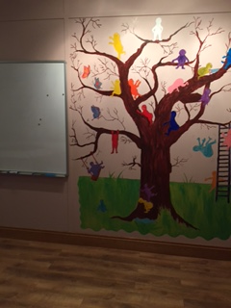

Structure of the Nurture Group:
Within the Nurture Room there are 4 key areas; Kitchen, Home, Play and Work.

The Haven

Holy Trinity College

Date of publication
The kitchen area is used for breakfast and snacks. Every morning a different teacher is invited for breakfast. This helps to build bonds and the pupils get to know other members of staff.
The home area is used as a relaxing area, ie: sofas and books where the children enjoy reading and down time.

The Play area is incorporated into the work area and helps ensure that learning is enjoyable and fun.
A lot of subjects are taught through a thematic approach. The different themes include literacy, numeracy, ICT, PE, art and many other subject areas.
“By focusing on emotional well-being and resilience, Holy Trinity College are aiming to equip their young people with the resources to meet diverse challenges and enhance their capacity to engage more fully in learning. The Nurture Group is a warm and vibrant area, staffed by a dedicated and enthusiastic team who care about the young people on a level beyond their academic development.”
Susan Irwin, Educational Psychologist

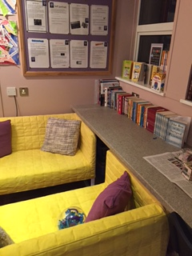
The nurture provision is for a period of 1-5 terms depending on each pupil’s needs before re- integration back into the 6 period day classroom setting.

Staff
Brenda Geraghty
Nurture group teacher

Sinead Collins
Pastoral support officer

Grainne McKernan
Art therapy teacher

Aileen Devlin
Nurture teaching
assistant

We have recently achieved the Derrytrasna Award for Excellence in Pastoral Care.
Why Nurture?
Nurture groups are a specialist form of provision for pupils with social, emotional and behavioural difficulties. First and foremost, nurture groups focus on having the student form attachments to loving and caring adults at school, unconditional positive regard being the most powerful mechanism for change. The social and developmental targets for each child are devised using the Boxall Profile- a detailed assessment of social, emotional and behavioural functioning. When the appropriate targets are met the students are reintegrated back into their mainstream class full time.
The purpose of nurture provision is:
‘To provide a carefully routined day, where there is a balance of learning and teaching, affection and structure within a home like atmosphere’
(The Nurture Group Network)

Aims of our Nurture Group:
-Increase educational engagement
-Ensure academic progress
-Foster emotional wellbeing
-Reduce aggression and incidents of withdrawn behaviours
-Create a more inclusive ethos
-Remove barriers for learning
-Working in partnership with parents and teachers

The six principles of Nurture:
1) Learning is understood developmentally
2) The nurture room offers a safe base
3) The importance of nurture for the development of wellbeing
4) Language is a vital means of communication
5) All behaviour is communication
6) The importance of transition in the lives of children and young people

