Contingency Measures in the Event of a School Closure

Accessing work from home

- Log on to the MySchool area, it is available via the School website homepage www.holytrinitycollege.org
- or via www.c2kschools.net

When in the Myschool personal documents can be found in the files and apps area

View all – files and apps - MyFiles
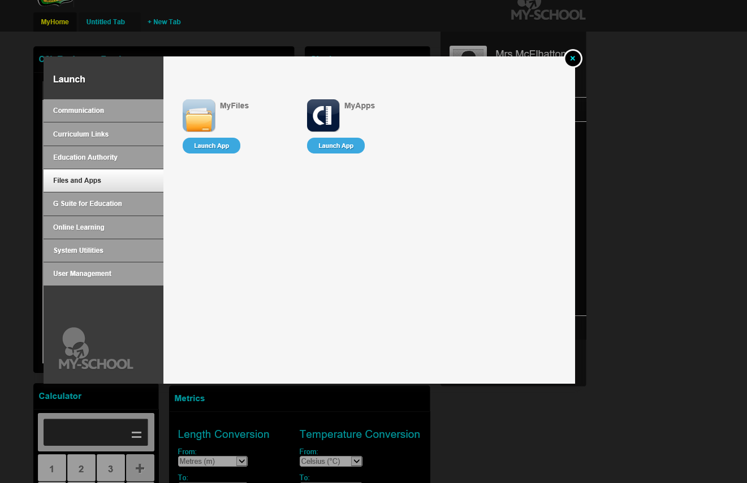
NOTE: This is just for pupils own personal Documents

All other work relating to subjects will either be emailed or accessed via Google Drive
To access this go to
G Suite for Education – Google Drive or Google Classroom
Or use the following links
https://drive.google.com/drive/shared-drives
https://classroom.google.com
Pupils should use their @c2ken.net email extension e.g jsmith112@c2ken.net.
If a new classroom has been set up, Students will usually get a link to the Classroom that their work is in and a code to access it so you may need to check emails and make a note of this code.
For students who already use google drive for online lessons for particular subjects,
Please continue to do so the normal way.
For subjects that you don’t normally use google drive for – materials are now made available through a shared drive and you will find the link to this in your email.
If you have not received the email, please click Shared Drive within Google Drive
KS3 and Ks4 & 5 will be available there.

Emails can be accessed via Office 365 on the MySchool homepage
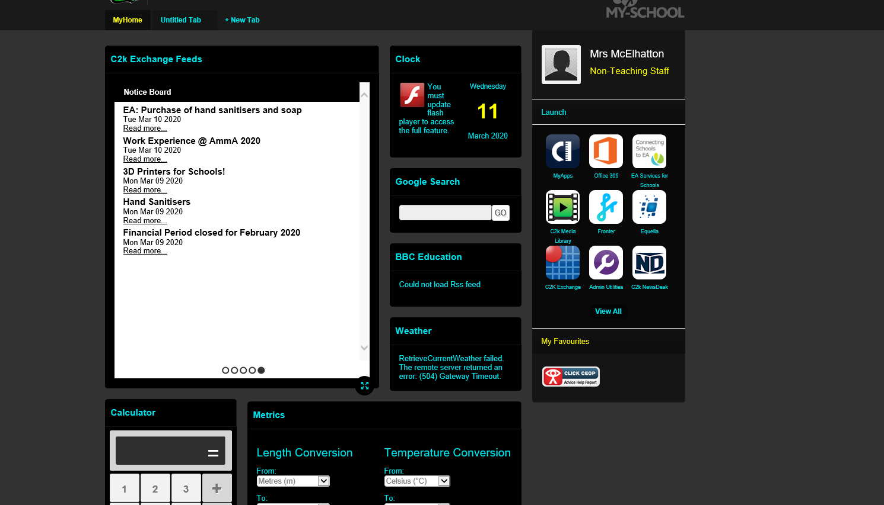
You will be asked to continue sign in, and it may prompt another log in

If so, ensure you put @c2ken.net after your username then your normal password

You can use the link in your email to access the google drive or access by view all in the myschool area as shown above.

NOTE: Please check regularly

When you are in Google Drive, it will look like the following – All subject areas are in here.

If there are any issues, please private message the School Facebook page or email the school info@holytrinityc.cookstown.ni.sch.uk and we will try to help resolve any technical problems/passwords.

REMEMBER:
Microsoft office is free to download using our c2k username (remember to use @c2ken.net) the download is available within the office 365 app.

