HOLY TRINITY COLLEGE

STUDY SKILLS GUIDE

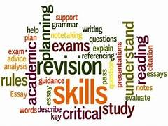

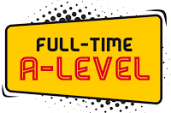
Welcome to Sixth Form at Holy Trinity College.

You have now embarked on A’Level study. You have chosen a minimum of 3 subjects. Whether you have chosen the Academic route or the Applied route, or a combination of the two, you will have coursework assignments and essays to complete and examinations to prepare for over the next 2 years of study.

In addition to these qualifications, you will be expected to take part in extra-curricular activities inside and outside of Holy Trinity College. Many of you will wish to continue your studies at University and whilst you will need to achieve the required grades for your chosen course, other experiences you gather along the way will further enhance your application to University.

This Study Skills Guide will hopefully help you develop these essential skills and ensure success in the A’Level subjects you have chosen. It is difficult to generalise about study skills, and you will need to work with your teacher to find your most effective approach to study. However, the section begins with ten top tips that everyone can follow:-

- Get yourself organised – keep your student diary up to date, listing work given, work completed and work outstanding;

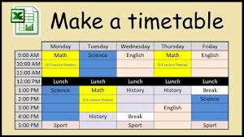
- Try and stick to a regular work rota – do a little bit of study often, rather than leaving huge amounts of work to the last minute before a deadline – definitely not the night before!! Late work is invariably rushed, often incomplete and of inferior quality and by starting an Assignment well in advance of a deadline you will get the chance to ask your teacher for help if you need it.

Most A’Level students need to work a minimum of 2-3 hours per night, including weekends OUTSIDE of lessons.

- Work in a studious environment – not somewhere where you will be distracted. At home, work somewhere where you will not be disturbed (and where you can leave books, folders etc.. safely). If you do need to work on a computer/laptop, make sure you are not signed into any social networking sites (Facebook/Instagram) to avoid distractions.

- Define your work tasks - make sure you understand what is expected of you. Seek clarification from your teacher if you are uncertain about work given.

- Don’t be afraid to ask for help – Don’t pretend you know something when you don’t!! ask your teacher for help and guidance in completing Assignments/Essays. Your teachers are very approachable and will help you in whatever way they can.

- Use all available resources – teachers, textbooks, Miss McAdoo in LRC, the Internet, newspapers, media and fellow students.

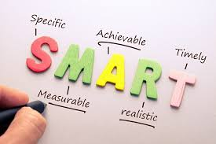
- Motivate yourself – have a goal to aim for. Set yourself SMART goals over the 2 years of study and make every effort to achieve them.

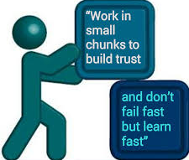
- Work in attention span units – few students can work effectively for more than one hour before their concentration starts to ebb (this is particularly so with revision!). Divide your working time up into attention span units – 40-60 minute, punctuated by short breaks.

- Get a dictionary – many exam boards penalise poor spelling and grammar at A’Level.

- The more you put in, the more you get out, both in terms of results and enjoyment.

READING AND MAKING NOTES

Reading is one of the core activities of A’Level study and you are faced with three specific challenges:-
- The volume of reading
- The complexity of the material you will read
- Trying to remember what you have read

A Reading Style
Reading is not a passive activity! You should be thinking about what you read:
- Do you agree with the author?
- What is the quality of the author’s argument?
- Do you have a different point of view?
- What counter arguments could you use?

Skilled readers vary their reading speed and method to suit both the material they are reading and their purpose in reading it. You ‘read’ a telephone directly rather differently than a novel! There are several different approaches to reading and below you will find some techniques you can use:-

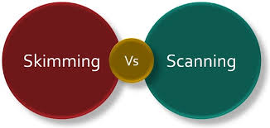
Skimming
This involves looking quickly through the book and reading only things like contents, headings, Introductions and Conclusions. It is a quick and efficient way of familiarizing yourself with a publication and is useful if you wish to check whether a book is relevant, or for finding particular information or ideas quickly.

Skimming is particularly useful for finding you way around a publication.
You may skim the newspaper to find articles you want to read, or a textbook to identify a relevant chapter.

Scanning
This is a very rapid search for important points. It may be a diagram, a title or a key word. The essential thing is that you deliberately ignore everything except the one item for which you are scanning. Scanning is useful when you want to identify a particular piece of information pertaining to your subject.

Reading to Understand

This involves detailed study of a chapter, passage or article in order to absorb all the major facts and ideas. You may read it more than once, and take notes to summarise what you have read. Reading to understand is useful when you want to study something thoroughly.

Word-by-mouth Reading
Very occasionally you actually need to read every word extremely carefully eg. when reading an English Literature text or an exam question.

To study efficiently you must learn to vary your reading style and become proficient at each type of reading. By developing the ability to switch from one method of reading to another you will vastly increase your studying efficiency.

TAKING NOTES

Clear, accurate and comprehensive notes are vital to A’Level success. Good notes are invaluable as they act as:-
- A form of ‘external memory’ – a kind of extension to the memory capacity of your mind – enabling you to have ready access to a far wider range of knowledge;

- A symbol of progress – notes provide you with evidence of the work you have done and so make an important contribution to your morale;
- A means of pulling the course together.

The Process of Note Taking
Highlight and underline texts IF THEYARE YOUR OWN. Highlighting and underlining focus your attention on the text and makes you think about what they key concepts and issues are.

Taking notes forces you to THINK: to grapple with the ideas in the text as you read them, because you have to decide what to write down and how to say it. What is more, if you read without taking notes, no matter how good your memory, you will find that ideas gradually drift away from you.

Your notes should:-
- Summarise the main theme of an article/chapter
- Highlight the key ideas and arguments used
- List out any important statistics/fact

Notes are best presented in point form or under subheadings with key points/ideas underlined and highlighted. They may contain quotes, BUT BEWARE OF COPYING TOO MUCH NARRATIVE STRAIGHT FROM THE TEXT. Notes should be detailed enough to cover all the relevant material in depth necessary for A’Level study, but not too detailed to make revision difficult or tiring and overly time consuming. Notes can be made more concise by the use of abbreviations.

Filing Notes – in an ordered fashion is a vital skill. Too many students lose notes or are unable to access material when they need it because of chaotic or non-existent filing systems. Lever arch files, box files or large hard-back exercise books are ideal for the purposes of keeping notes in an ordered way.

If you are Absent - as with any subject it is vitally important that you have a comprehensive, clear set of notes. Make sure if you are absent from school that you ask someone in your class for a copy of anything you have missed. This is YOUR responsibility, not the teacher’s, although of course your teacher will be more than willing to go through any problems or concerns you have once you have copied up work you have missed. Indeed, some teachers may have notes available on Google Drive or Google Classroom for easy access.

Resources
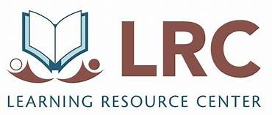
There are many resources available to help you complete A’Level study at Holy Trinity College.

Miss McAdoo has a very well resourced Learning Resource Centre (LRC) and all students are encouraged to access this during their ‘study’ periods.
There are also laptops available in some departments but students are encouraged to bring their own devices in so they can continue working during ‘study’ periods. They can be stored safely in the study rooms.

Computers – there is a wealth of information on the internet which offers huge scope for research for projects and for general interest.
However, you should consider the source of information on the web – there is little censorship or vetting of material so you need to check the reliability of your sources. Despite their significant advantages, computers present two distinct pitfalls:-
Plagiarism – copying information from the internet without acknowledging it is plagiarism. You must cite your sources or make reference to them in your bibliography. Failure to do this may result in disqualification from individual modules or entire subjects. In the Sixth Form Code of Conduct, it will also warrant a written warning. Information is there for you to access but you must summarise it in your own words and draw your own conclusions – NOT someone elses!

Distraction – social media sites like Facebook, Instagram etc are central part of teenagers’ lives – this is how you communicate with your peers. Inevitably, they are also a major distraction when you are attempting to complete homework/coursework etc… To avoid distraction, do not log in to these sites whilst you are studying; leave your phone in another room so you won’t be tempted to look – use your phone as a ‘reward’ when your study session is finished.

Textbooks – the use of a textbook depends on the subject. In most subjects, the main use of your textbook is a source of information and questions on specific topics. You may also be asked to take notes directly from the textbook.

Past Papers – These in some ways are the most valuable study aid you have. After all they represent exactly what it is you will be asked to do in the exam. There is no substitute for practicing past papers. You can download these from the examining board websites but usually your class teacher will provide you with packs of these prior to mocks or actual examinations. Make sure you avail of this very importance resource.

Once you have completed a topic in class, it is a very useful method of revision to complete questions on that topic from your bank of past papers. When you have the course completed it is useful to complete a whole test paper under exam conditions.

One important point to remember is that quality comes before quantity. Yes, you need to practice plenty of past papers but don’t be tempted to rush through them missing out the bits you can’t do. There is absolutely no point in doing 10 past papers if you only do the bits that you could do already! You will learn very little. Past papers can help you identify areas that you are unsure of. The more past papers you complete and understand the better prepared you will be for the actual examination.

Teachers and Homework – there are TWO main points to homework: firstly for the teacher to check that you understand the work and have grasped the relevant concepts and secondly for you to practice required techniques and to check YOU understand the work.

Copying homework from someone else and passing work off as your own is dishonest and serves no purpose. Don’t fool yourself into thinking ‘I’ve got away with that’! Do you understand it? If so then you should have done it yourself …. If you don’t understand it, then you should ask your teacher who will only be too willing to go over it in class in the next lesson.

THE THREE GOLDEN RULES

- Slow and steady wins the race – every time – this means study little and often from DAY ONE. There is nothing worse than playing ‘catch up’. That may have worked last year when you were doing your GCSE’s but A’Levels are a totally different ball game – ask the present Year 14 students, they will tell you!

- Divide your time fairly between subjects – it is easy to become bogged down in a particular subject if there is a test/exam/essay or coursework due but you must endeavor however to keep the other subjects going at the same time.

Some students in the past have left themselves in a difficult position by concentrating on one particular A’Level subject, to the detriment of the others. A little forward planning and managing your time better can prevent this from happening to you.

- Seek advice and assistance before things get out of control – the teachers at the College are here to help you – your Form Teacher, Head of Year and myself, Head of Key Stage 5. If things are getting too much for you talk to someone who can help. Your teachers are all very approachable and would want to know if you are struggling with something so they can help. There are very rarely problems that are insurmountable provided you are willing to work through them with our support. In terms of your mental health and wellbeing, we have our Pastoral Support Officer, Sinead and our Familyworks Counsellor, Una and myself who are all here to help you and signpost you to other agencies.

Group Discussions

In Sixth Form there will be more opportunity for group discussion than was the case when you were doing GCSE examinations. Group discussions are important as they help you articulate ideas and arguments in a clear and coherent manner, build self confidence, teach you to appreciate the viewpoints of your peers and help support group learning in the classroom.

How to make group discussions work for you

- Contribute to the group discussion and join in – everyone has something valid to contribute and you have the same right as everyone else to take part;
- Contributions can be simple;
- If a discussion is pre-planned and part of your subject assessment, then prepare for it!
- Show tolerance towards the views of your peers even if you don’t agree with them. Don’t forget, many issues are so complex that there is never just one right answer.

ESSAY WRITING

In order to produce an essay to a high standard here are some key steps to follow:-

- Think about the essay title – look out for command verbs such as explain and evaluate which will set the parameters of your answer. Underline key words and ensure all aspects of the questions are being addressed. Before you begin to prepare for an essay you must have a clear idea of what the question wants, and if necessary seek clarification from your teacher. In some cases your teacher may give you an outline to follow.
- Gather together material for the essay – look back through your class notes to find out what is relevant to the question set. Using relevant material taken from other sources beyond basic textbooks impresses examiners. Without thorough research, you will not be familiar with the range of arguments and depth of supporting details necessary to score highly.
- Get some ideas down on paper - by writing notes for your essay, you have already begun the process of getting ideas onto paper. Once you have completed the gathering together of material for your essay you must begin to decide what you are going to say – the best approach for this is BRAINSTORMING, jotting down your thoughts relating to the title of your essay.

- Organise material and devise an essay plan then write the essay – dividing up your brainstorm ideas into some order will form the basis of a logical and structured argument for your essay. Make sure you have an introduction outlining the topic to be discussed, ensure your information is relevant, have a logical and developed argument and finally a conclusion which summarises the main points are all features of a good essay structure.
- Review the essay – check your spelling, punctuation and grammar. Proof read your essay to ensure it flows well and that you have included sufficient explanation. Most importantly, check that you have actually answered the question!

EFFECTIVE STUDY and REVISION TECHNIQUES

There is no miracle approach to A’Level study and success. However, it is possible to ‘work smarter not harder’! Get the most out of your revision and study by following these points:-

- Get Yourself Organised
- make sufficient time for study outside of the classroom. You should be spending at least 15 hours per week outside of class time;
- make the most of ‘study’ periods in school - plan and use your time wisely and certainly DON’T prevent others from using their ‘study’ time wisely!
- Try and meet all your deadlines and do not fall behind. This is very important, especially if you are off sick. You don’t want to get too far behind in your work and become overwhelmed.
- Find somewhere at home that you can complete work quietly and without interruption. The LRC remains open after school for individual study and many classrooms are open, including ICT rooms for students to complete coursework.
- Many of you may have a part-time job. This in itself is a great opportunity to develop essential skills. However, as exams approach you must give academic work increased priority – cutting back hours worked is a wise move.

- Reading
- Read around your subject (daily newspapers, Internet and other publications. Our LRC has a number of these that you can borrow.
- Ask your teacher for help if you don’t understand something that you read
- Make summaries of what you read in your notes
- DON’T copy other students’ work or plagiarise

- Note taking
- Clear and concise notes are best remembered
- Highlight key words and phrases
- Summarise you own notes (consense them) into a series of key points – use cue cards, spider diagrams/mind-maps, post-it notes, revision guides etc…

MIND MAPS

Mind Maps are great for Revising Topics. Organising material visually can make it easier to recall in an exam.
Colour and images can help topics and information to stick in your memory
Mind maps can help you to identify the key ideas of a topic and find links between them, which can help you see the topic in different ways.

FLOW CHARTS
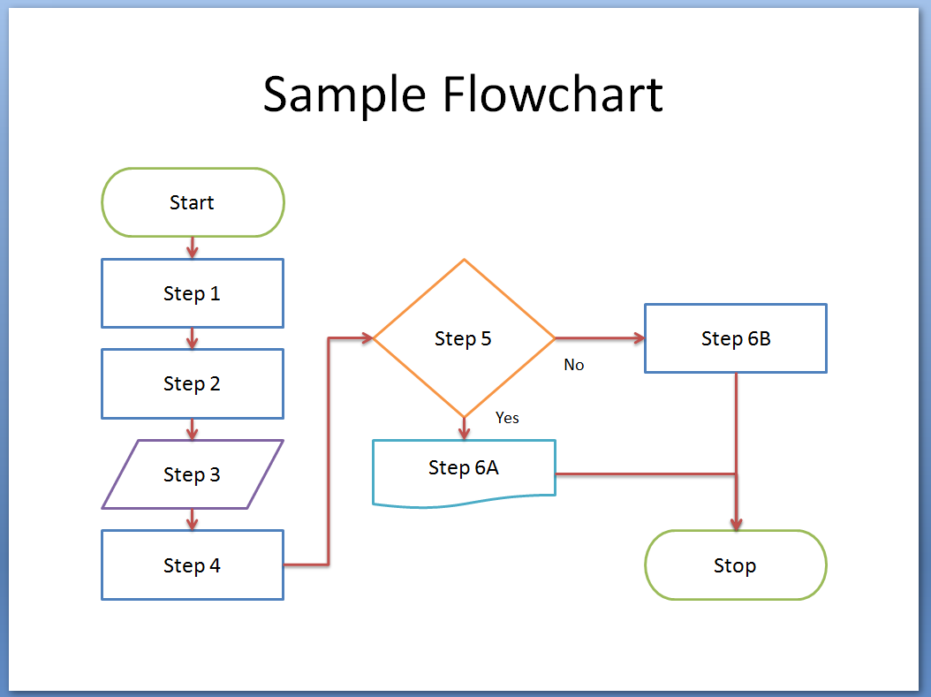
Flow charts are a type of diagram that show a process from beginning to end. They organize information clearly and you can use both words and images to show what happens next.
As long as your flow chart is clear and easy to use you are on your way to creating a good revision tool.
Flow charts can be used in many subjects:
- Business – to show the different stages within the supply chain
- History – a timeline of the events that led to WWII
- Chemistry – to set out the steps to a practical experiment
- Biology – to show how food passes through the digestive system

FLASH/CUE CARDS

These are a great revision tool. They have a question or prompt on one side and the answer or information on the other side!! They are a great way to test your knowledge. They can be useful for important dates, vocabulary, key words and definitions, formulae and labelled diagrams. After you have revised a topic, test yourself by writing exam questions and answers on your cards – even better use this method to revise with friends.

MEMORY TECHNIQUES

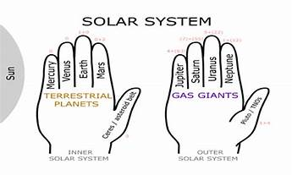
Using Mnemonics is an excellent way of remembering facts or information in a certain order. A mnemonic can be anything as long as it makes sense to YOU! – however, funny or rude mnemonics tend to be easier to remember!!

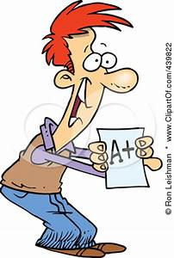

- Preparing for Exams
- Start revising early enough – months before the exam!
- Devise a revision timetable to make it easier to see what subjects/topics you need to revise
- Revise in approximately 45 minutes – 1 hour sessions with breaks in between to keep you focused
- Use all your revision techniques

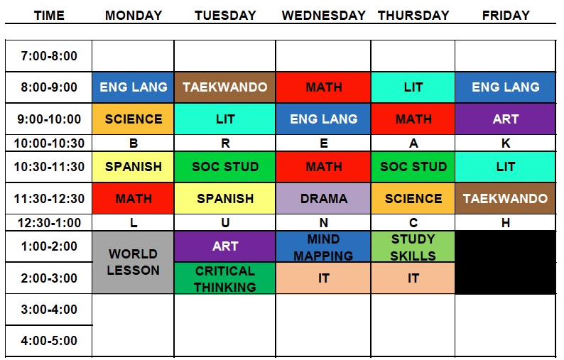
A REVISION TIMETALBE

When you devise your revision timetable, make sure you mix your subjects up. Split your revision of each subject into short, focused chunks spread over different days and several weeks – leaving a gap between them will help you retain the information better. As you go through the weeks of revision you may want to adapt your timetable. Also of something doesn’t go to plan one day, don’t panic – just amend your timetable and carry on. The most important thing is, if you go to the bother of making a good revision timetable, then use it!

- As exam day approaches
- Revise early in the day
- Check your exam timetable and the times your exams are on
- Arrive in good time to the examination hall/room
- Don’t let other candidates disturb you – focus on yourself and that you have prepared for the exam as best you can
- If you are anxious – try breathing exercises [3,4,5]
- Bring the necessary equipment needed to complete the exam

- In the Exam Itself
- Keep calm at all times [“If you can keep your head when all about you are losing theirs and blaming it on you, if you can trust yourself when all men doubt you …..” Rudyard Kipling]
- Read the instructions on the front page
- Read the questions carefully – make notes if you can of words/phrases that come to mind
- Plan your answer carefully ensuring you have answered the question correctly and have included as much relevant information as you can remember
- Write legibly and in a clear style using relevant terminology

- Before the allotted time is up, check over your work very carefully to ensure all questions are answered. Should something come to mind and you have run out of time, jot it down underneath your answer … it may be of use when the examiner comes to mark your paper
- When the exam is finished put it behind you. DON’T dwell on answers you didn’t put down – you have done your best now focus on the next exam!

I hope this guide will be of use to you throughout the next 2 years of Sixth Form Study at Holy Trinity College. Our aim is the see Sixth Form students leave as well-rounded young adults, who will excel in whatever their chosen career pathway is. The teachers at Holy Trinity College will endeavour to guide and support you along your A’Level journey. What we ask is that you give us 100% commitment to achieve your fully potential.

