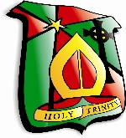
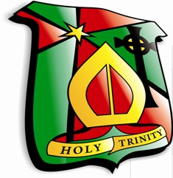 Post 16 Options 2022-2023
Route One
Option One | Option Two | Option Three | Option Four
English Literature  History  Geography  Maths | Sociology  Art  Health and Social Care  Sports Studies (Single Award) | Biology  Religion  Business Studies  Physics (CHS)  Music Performing (Single Award)  Travel & Tourism | Chemistry  Psychology  Media Studies (Single Award)  Agriculture (Single Award)  ICT (Single Award)  Engineering

Route Two
Double Award | Option Two
DA Art  DA Music Performing  DA Sports Studies | Chemistry  Psychology  Media Studies (Single Award)  Agriculture (Single Award)  ICT (Single Award)  Engineering

