HOLY TRINITY COLLEGE

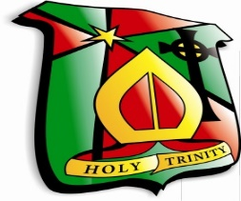

Relationships and Sexuality Education Policy

College Mission Statement

“Holy Trinity College is a Catholic Maintained school committed to high quality educational opportunities for each pupil to develop his/her unique talents to the full in a secure, caring environment”

(Revised: April 2022)

Promoting: Inspiration, Innovation, Excellence

Holy Trinity College Mission Statement

Holy Trinity College is a Catholic, maintained school committed to providing high quality educational opportunities for each pupil to develop his/her unique talents to the full in a secure, caring environment.

Aims of the College

- To be a community inspired by the Catholic faith, living out Gospel values, and reflecting all traditions of our Irish Cultural Heritage.
- To enable pupils to acquire a sense of purpose and have a good opinion of themselves by giving everyone access to a religious, academic, moral, social and physical education.
- To provide a wide, varied and effective curriculum to meet the needs of all pupils and with appropriate provision for pupils with special and additional needs, in an attractive school environment.
- To provide all staff – both teaching and support - with the necessary accommodation, equipment and training to achieve our Vision.
- To maintain a safe and healthy work environment where everyone will feel valued and their creative and innovative ideas will flourish.
- To involve Parents, Educational Agencies and Industry in the work of the school which in turn will benefit the greater Cookstown Community.
- To foster a sense of cheerful co-operation and provide a caring environment which promotes high achievement and self-esteem amongst both staff and pupils.

The Core Values and Beliefs of Holy Trinity College are:
- Respect for self and for the value, worth and dignity of each individual in the school community.
- The belief that all young people can learn, succeed at school, achieve, develop and grow in such a way as to live worthwhile, fulfilling adult lives.
- Treating all members of our school community with care, concern and compassion especially those in particular need.
- Promoting a sense of responsibility for one’s own actions.
- Tolerance and forgiveness.
- Inclusiveness and Equality of Opportunity.
- Endeavour and dedication to hard work.
- The pursuit of excellence.
- A strong sense of community.
- Honesty, Openness and Integrity.
- Loyalty to and Pride in Holy Trinity College.
- Valuing and using our God given talents.
- Seeking and working with the good in each individual.

Holy Trinity College view the development and implementation of a policy in Relationships and Sexuality (RSE) as an important step towards achieving our aim to develop all aspects of a young person’s personality and growth. The morals and values of our Catholic ethos are the core principles that underpin the teaching of RSE. Sexuality includes all aspects of the human person that relate to being male and female and develops throughout life. It is a complex dimension of human life and relationships.

As parents/guardians are the primary educators of their children, we will endeavour to engage in full consultation with them regarding aims, objectives and the teaching programme of this policy and their views will be considered when implementing and reviewing this policy.

In line with our school’s ethos, RSE should provide opportunities that enable pupils to:

- form values and establish behaviour within a moral, spiritual and social framework consistent with our Catholic ethos

- learn how to develop and enjoy personal relationships and friendships which are based on responsibility and mutual respect

- build the foundations for developing more positive personal relationships in later life

- make positive, responsible choices about themselves and others and the way they live their lives

Implementation and Review of Policy
Implementation of the policy will take place after consultation with the Governors in September 2021.

This policy will be reviewed every 2 years by the Head teacher, VP Pastoral RSE, Head of RE and the Governing Body and Staff. The next review date is September 2023.

When the finalised draft policy has been ratified by the Board of Governors, it will become the school’s agreed RSE policy. It should then be circulated within the school community. The entire staff should be familiar with the policy and aware of any changes required in curriculum delivery.

The Link Governor for RE/RSE/PD/Safeguarding in conjunction with the co-ordinators for these areas should address the Board of Governors and keep them fully informed.

Parents/guardian and pupils will be made aware of the school’s policy from the time of enrolment of the student (See Appendix 2 – Sample Letter to Parents). A contact person should be named in the policy to allow for comments and feedback on the policy.

Definition and Rationale for the Delivery of RSE

Holy Trinity College is committed to nurturing the personal growth and development of its pupils within a child centred, inclusive and secure learning environment where all pupils are cherished and valued. Relationship and Sexuality Education (RSE) is a lifelong process which encompasses the acquisition of knowledge, understanding and skills, and the development of attitudes, beliefs and values about personal and social relationships, gender issues and sexual identity. This policy is intended to provide a framework through which young people can develop the necessary skills, attitudes and values to deal with the challenges they may meet and to make informed decisions based on self-respect and self-esteem. The RSE programme acknowledges the importance and foundation established by informal learning from parents/guardians before any formal education takes place at school. Sexuality includes all aspects of the human person that relate to being male or female and is subject to change and development throughout life. Sexuality is an integral part of the human personality and has biological, cultural, psychological, social and spiritual dimensions. It especially concerns affectivity, the capacity to give and receive love; procreation and, in a more general way, the aptitude for forming relationships with others. It is a complex dimension of human life and relationships.

Relationships and Sexuality Education provides an understanding that positive, caring environments are essential for the development of a good self-image and that individuals are in charge of and responsible for their own bodies. It provides knowledge about the processes of reproduction and the nature of sexuality and relationships. It encourages the acquisition of skills and attitudes which allow pupils to manage their relationships in a responsible and healthy manner.

RSE is about the development of the pupil’s knowledge and understanding of himself/ herself as a sexual being, about what it means to be fully human, called to live in right relationships with self and others and being enabled to make moral decisions in conscience. RSE should give young people the information they need to help them develop healthy, nurturing relationships of all kinds, not simply intimate relationships. It should enable them to know what a healthy relationship looks like and what makes a good friend, a good colleague and a successful marriage or other type of committed relationship.

Rationale
The school is involved in relationships and sexuality education precisely because of our Christian beliefs about God and about the human person. The belief in the unique dignity of the human person made in the image and likeness of God underpins the approach to all education in a Catholic school. Our approach to RSE therefore is rooted in the Catholic Church’s teaching of the human person and presented in a positive framework of Christian ideals.

At the heart of the Christian life is the Trinity; Father, Son and Spirit in communion, united in loving relationship and embracing all people and all creation. As a consequence of the Christian belief that we are made in the image and likeness of God, gender and sexuality are seen as God’s gift, reflect God’s beauty, and share in the divine creativity. RSE, therefore, will be placed firmly within the context of relationship as it is there that sexuality grows and develops.

RSE will be firmly embedded in the PD/HE/LLW and the RE Curriculum as it is concerned with nurturing human wholeness and integral to the physical, spiritual, emotional, moral, social and intellectual development of pupils. It is centred on Christ’s vision of being human as good news and will be positive and prudent, showing the potential for development, while enabling the dangers and risks involved to be understood and appreciated.

All RSE will be delivered in accordance with the Church’s moral teaching. It will emphasise the central importance of marriage and the family whilst acknowledging that all pupils have a fundamental right to have their life respected whatever household they come from.

Our programme enshrines Catholic values relating to the importance of stable relationships, marriage and family life. It also promotes those virtues which are essential in responding to the God’s call to love others with a proper respect for their dignity and the dignity of the human body. The following virtues will be explicitly explored and promoted: faithfulness, fruitfulness, chastity, integrity, prudence, mercy and compassion.

Our Mission Statement commits us to the education of the whole child (spiritual, physical, intellectual, moral, social, cultural, emotional) and we believe that RSE is an integral part of this education. Furthermore, our school aims state that we will endeavour to raise pupils’ self-esteem, help them to grow in knowledge and understanding, recognise the value of all persons and develop caring and sensitive attitudes. It is in this context that we commit ourselves:

In partnership with parents, to provide children and young people with a positive and prudent sexual education which is compatible with their physical, cognitive, psychological, and spiritual maturity, and rooted in a Catholic vision of education and the human person.

Aims of RSE

Our RSE policy includes the following aims. In line with the school’s ethos and CCEA guidelines the Relationships and Sexuality Education Policy of a Catholic school aims to:

- promote a Catholic vision of sexuality that reflects selfless love, respect and commitment within a moral, social, spiritual framework

- help young people appreciate their worth, dignity and uniqueness as children of God

- enable young people to appreciate sexuality as a gift from God

- promote an appreciation of the value and sanctity of human life and the wonder of life from the moment of conception to the moment of natural death

- value the gifts of marriage and the family, and to persevere in a love strengthened by the virtues of generosity, commitment, fidelity and patience

- understand marriage as the sacramental sign of God’s love for his Church

- enable young people to grow in holiness by acting responsibly and generously towards others.

- value the concept and qualities of consent in relationships and understand the law in relation to consent

- recognise that compassion, forgiveness, mercy and tolerance are essential dispositions to develop within relationships

- Understand that being single and chaste is a virtuous, positive and fulfilling option

- promote respect for all individuals regardless of sexual orientation, race, gender or creed

- encourage the young to witness to human dignity at all times online

- encourage the young to see social media as another tool to reach people with the message that sexuality is a gift from God, not to be squandered and abused

- recognise common mental health issues such as anxiety, depression, disordered eating, self-harm and compulsive behaviours in themselves

- Objectives of RSE

In line with the school’s ethos and CCEA guidelines, the Relationships and Sexuality Curriculum attempts to enable pupils to:

- realise that relationships can cause strong feelings and emotions including sexual attraction

- know the features of positive and stable relationships (including trust, mutual respect, honesty, equality) and those of unhealthy relationships (including imbalance of power, coercion, control, exploitation, abuse of any kind)

- help pupils cope with the breakdown of a relationship and the effect of change, including loss, separation, divorce and bereavement

- develop a positive sense of self-awareness, and the skills for building and maintaining self-esteem

- acquire and develop an appropriate vocabulary to discuss feelings, sexuality and development

- cope with the social, physical and emotional challenges of growing up

- understand human physiology with particular reference to the reproductive cycle, human fertility and sexually transmitted infections and diseases

- value family life and appreciate the responsibilities of parenthood

- understand different family structures, and the diversity of family life

- recognise the need for self-control and the importance of the virtue of chastity

- explore the moral and ethical issues surrounding sexuality

- recognise peer pressure and have strategies to manage it

- recognise the need for online safety

- recognise the impact of drugs and alcohol on choices and sexual behavior

- be aware that the media portrayal of relationships may not reflect real life and understand the possible impact of this on people’s expectations of relationships

- help young people to become aware of the pervasive prevalence of pornography on the internet which can destroy and degrade human sexuality and relationships and reduce people to objects for gratification

Skills Promoted (including personal and social)

Pupils will develop the ability to:

- form and maintain healthy, positive relationships which reflect the dignity of the human person

- make sound judgements and good choices

- manage emotions within relationships and the breakdown of relationships with sensitivity and dignity

- manage conflict positively and enable pupils to recognise the value of difference

- critically evaluate a wide range of information, opinions, attitudes and values

- develop the communication skills of active listening, negotiation, offering and receiving constructive feedback and assertiveness

- cultivate mercy and compassion, learning to forgive and be forgiven

- develop skills and strategies to respond appropriately to exploitation, bullying, harassment, and control in relationships (including the unique challenges posed by online abuse and the unacceptability of physical, emotional, sexual abuse)

- recognise when a relationship is unhealthy or abusive (including the unacceptability of both emotional and physical abuse or violence including forced marriage and rape

- be able to access support for self or others at risk

- develop the skills to challenge sexist, homophobic, racist and disablist language and behaviour

- evaluate the effect of alcohol and drug use on decision making and personal safety

- build resilience and the ability to resist unwanted pressures, recognising the influence and impact of the media, internet and peer groups and so develop the ability to assess pressures and respond appropriately

- develop coping strategies to overcome mental health issues and to recognise when they need to employ strategies to re-establish positive mental health including managing stress and anxiety

Inclusion and Special Education Needs (SEN)

In a Catholic school that seeks to honour individuals’ giftedness and be inclusive, it is essential that a school’s RSE policy attends to those pupils with special education needs.

The Church affirms the right of every individual to be treated equally. All pupils, male and female have a right to an education which adequately prepares them for adult life, regardless of their age, gender, culture, sexual orientation, disability status, religion or social class.

Schools must ensure that young people with SEN in mainstream schools have appropriate, accessible and relevant Relationships and Sexuality Education. Schools may need to engage in the careful planning and adapting of resources and teaching activities to ensure that there are no barriers to participation or learning for pupils with SEN compared to their peers.

It is particularly important that schools communicate with parents or carers of young people with SEN about the content of the programme and the date when classes will cover certain teaching activities/themes. This communication will allow for parents/carers to reinforce learning at home.
It is widely recognised that pupils with SEN are more vulnerable to all forms of abuse and exploitation. Teachers must try to ensure that they develop the knowledge, understanding and skills of pupils to enable them to:

- identify inappropriate and exploitative behaviour;

- help develop their own prevention strategies to stay safe;

- recognise and build healthy relationships; and

- know who they can talk to.

We will ensure RSE is sensitive to the different needs of individual pupils in respect to pupils’ different abilities, levels of maturity and personal circumstances; for example, their own sexual orientation, faith or culture and is taught in a way that does not subject pupils to discrimination. Lessons will also help children to realise the nature and consequences of discrimination, teasing, bullying and aggressive behaviours (including cyber-bullying), use of prejudice-based language and how to respond and ask for help.

Holy Trinity College will review and evaluate all the resources chosen before the pupils use them to ensure that they are inclusive and consistent with the school’s moral and value framework. All new RSE programmes, either developed within the school or presented by external agencies, should be brought to the attention of the Diocesan Advisors for review and accreditation.

RSE Teaching Resources will:

- Reflect the ethos of the School

- Be age-appropriate, inclusive, and sensitive to the pupils’ needs and experiences; and

- Be factually accurate, up-to-date and make clear distinctions between fact and opinion.

- Inappropriate images should not be used under any circumstances and schools must ensure that they protect pupils from accessing unsuitable material on the internet. Schools should inform parents or guardians about any materials that pupils will be exposed to, particularly if these are of a sensitive nature.

Timetabling of RSE

RSE is not timetabled discreetly in Holy Trinity College. An audit carried out in May/June 2021 indicated that RSE content and specific issues have been provided for through the following curricular areas – RE, PD, LLW, Science, Home Economics, Child Development, Health and Social Care.
Class sizes do not exceed 25 pupils and classes are mixed gender.

Where appropriate, the skills and expertise of outside agencies and professionals may be accessed. Where this occurs, Holy Trinity College will be satisfied that the contributions from informed outsiders are an integral part of the whole programme and in harmony with the aims and ethos of the school. They will ensure that all teaching is rooted in Catholic principles and practice.

It is essential that all outside visitors/speakers be approved by the Senior Pastoral Team.

A preliminary visit to the school to discuss ethical/practical considerations is advised. Appropriate follow up in relation to guest speakers is also advised.

The Pastoral Team and teachers involved in the delivery of RSE should ensure that resource materials obtained from other agencies and presentations by outside speakers are in harmony with the ethos of the school.

It is essential that all external agencies supporting RSE should sign a service agreement (see Appendix 1) agreeing with the RSE policy of the school and the underpinning ethos of the school and that this record is kept in a safe place as part of the delivery of RSE and for authenticity.

It is vital that any outside agency/individual delivering a support session in a school;

- receives a copy of the school’s Relationships & Sexuality Education Policy;
- is made aware of and adheres to the school’s Child Protection Policy;
- receives a copy of the school’s policy on the use of outside agencies/visitors;
- agrees to respect the ethos of the school;
- is made aware of the issues around confidentiality;
- is vetted as appropriate

Parents/guardians should be made aware in advance of the use of outside agencies. Schools should explain the type of activities which will take place to ensure that parents and guardians have the opportunity to raise any concerns they might have before the visit. Doing this will also have the added benefit of letting parents or guardians know what is going on and strengthen ties between home and school.

During the session the teacher/s should be present at all times. Afterwards the teacher/s should provide pupils with the opportunity to discuss their experience/s and honestly evaluate the session/s. Schools can use their student feedback to inform future planning and provision along with any evaluation carried out by the outside agency/individual.
Communication with Parents and Guardians

Holy Trinity College actively promotes the implementation of RSE and parents/guardians will be fully informed of the content, timing and the delivery of the programme in order to enable them to support the work of the school and to enable parents to discuss the topics and issues raised by the programme with their children.

This could be achieved by sending an outline of programme home either
- at the beginning of school year or
- just prior to the commencement of the programme

School Website
The RSE policy will be published on the school website to make it available for parents/guardians to download.

Ensuring the Curriculum is balanced

While promoting Catholic values and virtues, we will ensure that pupils are offered a balanced programme by providing an RSE programme that offers a range of viewpoints on issues.

Pupils will also receive clear scientific information as well as covering the aspects of the law pertaining to RSE relating to forced-marriage, abortion, the age of consent and legislation relating to equality. Knowing about facts and enabling young people to explore differing viewpoints is not the same as promoting behaviour and is not incompatible with our school’s promotion of Catholic teaching. We will ensure that pupils have access to the learning they need to stay safe, healthy and understand their rights as individuals and to relate to other individuals in a mature and respectful way.

Relationship to other Policies and other Curriculum Subjects
To ensure consistency all school policies should strive to be consistent and coherent within the framework of the overall school development plan. The RSE policy is developed in this context and shares links with, the following policies:
Religious Education
Teaching and Learning
Child Protection/Safeguarding Children
Personal Development
Anti-Bullying
Positive Behaviour
Drugs Policy
Internet Safety/E-safety
ework
- Learning about RSE in PD, HE and RE classes will link to other school subjects…
Teachers of supporting subject areas should be informed of the content and timing of the delivery of RSE, and in so far as possible Relationships and Sexuality Education will be taught in a cross-curricular way. The following subject areas could contribute to a cross-curricular approach:
Child Development
Drama
English
Home Economics.
Health and Social Care
Learning for Life and Work
Physical Education
Religious Education
Science & Technology
A school audit of subject content is a useful tool in determining which subjects to include in the programme.

Responding to pupils’ Questions and Sensitive Areas

Holy Trinity College’s RSE policy and approach to teaching and learning must, of course be sensitive to specific issues that arise in the life of pupils and in the overall life of the school. Some of those sensitive issues are outlined below to provide schools with guidance in terms of the formulation of policy and the delivery of programmes. Each of these issues should be understood as an important opportunity in the life of the school to present to pupils, in an invitational manner, the Church’s rich understanding of life, relationships and human sexuality.

Schools should acknowledge the right of pupils and others to disagree with the Church’s perspective, and their right to respectfully offer alternative perspectives and to engage in open and productive dialogue. However, while there may be differing perspectives on issues, the school, adopting an invitational approach, should not avoid teaching what it is that the Church professes.

Boundary Setting
It is essential to set parameters for the teaching of sensitive issues. Having an agreed Code of Conduct will ensure that the right to privacy for both student and teacher is always respected. In terms of such a Code of Conduct, it is important that schools:

- Support the parents. Parents may want to speak to someone at the school about one or more of these issues.

- Arrange a meeting with the parents and relevant support agencies to consider any appropriate measures of support that may be needed to ensure the needs of the student are met.

- Follow school procedures for monitoring the well-being of student/s.

- Provide time and safe spaces for young people, in an age and stage appropriate way, to engage at a deep level with these issues, to dialogue with their peers and their teacher around them and to be invited into a rich understanding of the Church’s teaching in these areas.

A host of DE IMatters flyers with advice, useful websites and telephone numbers are available in Appendix 5
Sexual Orientation

In accordance with the Catholic ethos of our school, we uphold the Church’s teaching that the meaning and purpose of sexual intimacy is fully realized in the sanctity of marriage between a man and a woman, faithful to one another for life and open to the possibility of transmission of new life, while recognizing and respecting the different views of others. All pupils have the right to learn in a safe environment, to be treated with respect and dignity and not be treated any less favourably or isolated in any way on the grounds of their sexual orientation. Antagonism/bullying or other forms of abuse against pupils who reveal that they are homosexual will not be tolerated by the school. Respect for all people regardless of sexual orientation will be promoted in line with the school ethos – no pupils should be isolated on the grounds of their sexual orientation. Pupils have the right to hold different views/lifestyles in a peaceful manner.

The Catholic ethos of the school ensures that gospel values, inclusivity, equality and respect for all and the right of everyone to learn in a safe and secure environment where all are treated with respect and dignity. The ethos of a Catholic school supports the guidance produced by the Equality Commission on eliminating sexual orientation discrimination. This guidance relates to the Equality Act (Sexual Orientation) Regulations (Northern Ireland) 2006 and the guidance from the Equality Commission (NI) in March 2009.

In the school anti-bullying policy, specific reference should be made to homophobic bullying, transgender bullying, cyber bullying, sexual harassment and bullying for other reasons relating to sex, gender, or relationships.

‘Bullying on the grounds of sexual orientation is as unacceptable as it is in any other situation where someone is mistreated or bullied because of their differences from those who are perceived to be the majority. All issues relating to bullying on the grounds of sexual orientation will be dealt with appropriately in line with the school’s anti-bullying policy.’

Pastoral Care of Young People with Gender Dysphoria
The disclosure of gender dysphoria by a child or young person is first and foremost a pastoral and welfare issue. As such, the priority of the school is to create a safe environment in which the vulnerable child can receive the support that they require. (See Appendices 3 & 4)

Family Planning

In Familiaris Consortio (1981:14) Pope John Paul II spoke of God’s plan when he said that marriage is ‘the foundation of the wider community of the family,’ and that the ‘institution of marriage and conjugal love are ordained to the procreation and education of children.’

In accordance with this, Catholic teaching places sexual intercourse within the Sacrament of Marriage and the use of any artificial means of preventing procreation is not acceptable.

Catholic teaching on family planning will be presented and pupils will also be provided with accurate information about methods of artificial contraception in an age appropriate and sensitive manner.

Sexually Transmitted Infections

It is important that pupils are provided with accurate, information about sexually transmitted infections, their transmission, the inherent dangers of risk-taking behaviour and how to obtain appropriate advice if they are concerned about their sexual health. Information on how to prevent the spread of infections should take note of the fact that the best way to prevent infection is to practice sexual abstinence before marriage and monogamy (inside marriage).

Digital Safety
The RSE Programme will teach pupils how to safely navigate the digital world. Technology plays an integral role in the lives of pupils which poses both opportunities and risks. The RSE Programme will raise awareness of potential threats or dangers posed by the Internet such as sexting, cyber-bullying, pornography, abuse and exploitation. Pupils will explore the implications of the law, the strategies they can use to protect themselves and where they can access advice and support if they are at risk.

Children will need to feel safe and secure in the environment in which RSE takes place. Effective RSE will provide opportunities for discussion of what is and is not appropriate in relationships. Such discussion may, at times, lead to disclosure of a safeguarding issue. Teachers will need to be aware of the needs of their pupils and not let any fears and worries go unnoticed. Where a teacher suspects that a child or young person is a victim of or is at risk of abuse, they are required to follow the school’s safeguarding policy and immediately inform the designated senior member of staff responsible.

While pupils should not be encouraged to disclose personal or private information in RSE classes, there may be times when they do talk about their own lives. Confidentiality should be respected unless a teacher becomes aware that a young person is at risk, in which case the appropriate action should be taken e.g. follow the procedures set down in Child Protection Procedures and Guidelines for Post Primary Schools or the Schools Substance Use Policy, and notify parents/guardians.

Where disclosure to parents/guardians may place a young person in a potentially harmful situation, the school must follow the Child Protection procedures as laid out in the Department of Education Circular 2017/04 Safeguarding and Child Protection in Schools: A Guide for Schools.
The student’s right to privacy should always be respected by both the teacher and the other pupils in the class but staff cannot give a guarantee of confidentiality to pupils on issues relating to Child Protection.

The RSE policy will be monitored and evaluated by the Head of RE in conjunction with the respective Heads of Department and by the VP with the Senior Pastoral Team.

Next Review Date: June 2022
Appendix 1 Sample Service Level Agreement for External Agencies
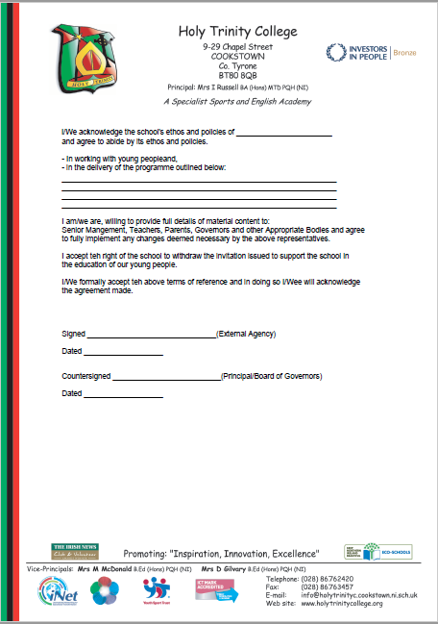

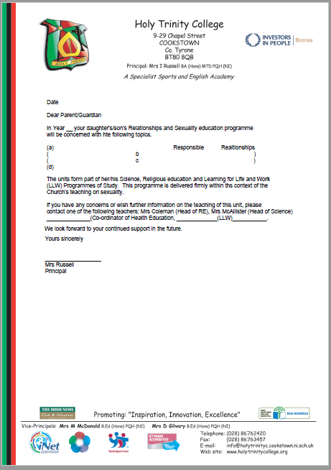
Appendix 2 Sample Information Letter to Parents

Relationships and Sexuality Education (RSE)
KS3 – Green KS4 – Red KS5 – Purple Assembly Theme - Black
Quality Indicators
The Status of the Family  - The Catholic Understanding of Marriage as a Sacrament – permanent, exclusive & life giving.  - Explore the roles and responsibilities of individuals within a variety of home and family structures  - Develop awareness of parenting skills  - Investigate some of the changing needs of family members at different stages of the life cycle  - Explore strategies to manage family scenarios | Year 11 PD syllabus The positive factors which contribute to healthy relationships in families. (LLW)  - Yr 12 GCSE Ethics – The Sacrament of Marriage. (RE)  Yr 11 OCN – Marriage (RE)  Yr11 Family and Home (Child Development)  - Yr12 GCSE Ethics – Personal and Life Issues – Types of Families and Parental responsibilities (RE)  Yr11 Family and Home (Child Development)  Year 8. Unit 8 – Family and home. Looks at the needs provided by a family, variety of home and family structures.  Responsibilities of different family members. (HE)  - Yr11 Caring for babies (Child Development)  - Yr12 GCSE Ethics – Personal and Life Issues –Parental responsibilities (RE)  Yr11 Childhood Development Stages (Child Development)  Year 8: Life Cycles & Growing up – Changes in puberty and adolescence.(Science)  Year 10. Unit 5 – Needs across the lifecycle. Physical, Intellectual, emotional and Social Needs. Needs of a  family with a disabled member.  Year 10. Unit 6 – Getting older. Looks at the social, emotional and economic aspects of aging. Having a  grandparent live with you. (HE)  5. Yr11 Family Lifestyles (Child Development)
The Virtue of Chastity  - In line with the ethos of the school and Christian morals, sexual abstinence before marriage and fidelity within it, will be presented as a positive, desirable and achievable option.  - The Catholic belief that the ideal context for sexual intimacy is a committed, permanent heterosexual relationship between a man and a woman.  - Explore the qualities of relationships, including friendships  - Explore the qualities of a loving, respectful relationship  - Develop coping strategies to deal with challenging relationship scenarios  - Develop strategies to avoid and resolve conflict  - Explore the implications of sexual maturation  - Explore the emotional, social and moral implications of early sexual activity | Year 11 PD syllabus The physical and emotional effects that unhealthy relationships may have on individuals. (LLW)  - Yr12 GCSE Ethics – Celibacy and Chastity – Christianity and Sex before Marriage  Yr 11 OCN - Marriage (RE)  Yr11 Natural Family Planning Guest speakers from Pure In Heart (Child Dev.)  - Yr12 GCSE Ethics – Ideal of Marriage in the Catholic Church (RE)  Yr11 How a baby is conceived (Child Development)  3.Year 10 Term 1 – Topic on Friendships (RE)  3A. Yr 11 Caring For Babies (Child Devlopment)  3B. Year 11 Taught Pastoral Programme- Unit 2- Relationships  Lesson 1- Learning Intentions:  1. Develop an understanding of what it means to respect yourself.  2. Encourage young people to think about who they are and what they believe or value.  3. Emphasise importance of learning to be happy in who we are before thinking about relationships  Lesson 2- Learning Intentions:  - Recognise the good qualities in dating relationships  - Recognise how to respect themselves  - Develop an understanding of how to foster good communication skills  3C. Year 12 Taught Pastoral Programme- Unit 2- Relationships.  Lesson 1- Learning Intentions:  To identify features of a healthy and unhealthy relationship  To identify attributes which make a good friend  Lesson 2- Learning Intentions:  To understand the difference between passive, assertive and aggressive.  To recognise the importance of being assertive in any friendship.  4, 7 & 8  Love4Life visiting workshop.  Year 11- Icebergs and Babies  Aim:To encourage pupils to have respect for themselves, relationships and sex.  Objectives:  - Facilitate understanding of relationships, and dispel myths about relationships  - Highlight link between premature sexual behaviour and abuse of alcohol  - Outline emotional effects of sex  - Teach respect for themselves and others  - Yr12 GCSE Ethics and Yr 11 OCN – Marriage and Why people marry. (RE)  Yr11 Parenthood (Child Development  4. Yr 10 – Qualities of a good friend. (RE)  - Yr 12 GCSE Ethics and Yr 11 OCN Marriage – How and when to seek support for difficulties in marriage. (RE)  Yr 11 Parenthood (Child Development)  Year 10 – Women’s Aid Talk  5. Yr 10 – Scenarios on good/bad friendships are explored (RE)  1/11/21 Friendship/Anti-Bullying Week  6. Year 8. Unit 8. Conflict resolution. (HE  6. Yr12 Discipline Strategies (Child Development)  6. Year 13 – Presentation – Nexus
The Sanctity of Life  - The value and sacredness of life is actively promoted.  - From the moment of conception, the embryo is a human being and must be recognised as having the rights of a person  - The most fundamental right for every human being is the right to life.  - Life is sacred from conception to the moment of natural death.  sacredness of lif  e will be value | 1.Yr 10 Term 3 – Sanctity of Life (RE)  - Yr12 GCSE Ethics and Yr11 OCN – The Sanctity of Life (RE)  Yr11 How a baby is conceived  Guest speaker from PRECIOUS LIFE (Child Development)  2.As above (RE)  Year 8: Reproduction (Science)  - Yr12 GCSE Ethics and Yr11 OCN – Catholic Church belief on conception and when life begins. (RE)  Yr11 How a baby is conceived  Guest speaker from PRECIOUS LIFE (Child Development)  3. Yr 10 Term 3 – Sanctity of Life (RE)  - Yr12 GCSE Ethics and Yr11 OCN – Life and Death Matters (RE)  Yr11 How a baby is conceived  Guest speaker from PRECIOUS LIFE (Child Development  4.Yr 10 Term 3 – Abortion and Capital Punishment (Roman Catholic beliefs and teachings on both) (RE)  - Yr12 GCSE Ethics and Yr11 OCN – Life and Death Matters – Abortion, Euthanasia and Capital Punishment. (RE)  Yr11 How a baby is conceived  Guest speaker from PRECIOUS LIFE (Child Development)
Sexual Orientation  - Uphold the Church’s teaching that the meaning and purpose of sexual intimacy is fully realized in the sanctity of marriage between a man and a woman, faithful to one another for life and open to the possibility of transmission of new life, while recognizing and respecting the different views of others.  - All pupils have the right to learn in a safe environment, to be treated with respect and dignity and not be treated any less favourably or isolated in any way on the grounds of their sexual orientation.  - Bullying or other forms of abuse against pupils who reveal that they are homosexual will not be tolerated.  - Respect for all people regardless of sexual orientation.  - Develop coping strategies to deal with challenging relationship scenarios  - Explore the implications of sexual maturation. | - Yr12 GCSE Ethics – Marriage in the Catholic Church, permanent, exclusive, life-giving, a Sacrament.  Views in other Christian churches on Marriage (RE)  2. Yr 10 –Term 1 – Prejudice and Discrimination (RE)  - Yr12 GCSE Ethics – Prejudice and Discrimination (RE)  Yr11 OCN – Prejudice and Reconciliation (RE)  PSNI – Internet Safety- Bullying & Threatening Behaviour workshop  3. Yr 10 –Term 1 – Prejudice and Discrimination (RE)  - Yr12 GCSE Ethics – Prejudice and Discrimination (RE)  Yr11 OCN – Prejudice and Reconciliation (RE)  - Year 11 PD syllabus - The effects of sexual orientation and gender identity on the well-being of a young person (LLW)  3. 4/4 Respecting all in Society  4. Yr 10 –Term 1 – Prejudice and Discrimination (RE)  - Year 11 PD syllabus Personal and social strategies to deal with bullying  - Yr12 GCSE Ethics – Prejudice and Discrimination (RE)  Yr11 OCN – Prejudice and Reconciliation (RE)  6.
Family Planning  - The Church teaching that the ‘institution of marriage and conjugal love are ordained to the procreation and education of children.’  - Catholic teaching that the use of any artificial means of preventing procreation is not acceptable.  - Pupils are provided with accurate information about methods of artificial contraception. | 1A Yr12 GCSE Ethics – Personal and Family Issues (RE)  Yr11 OCN – Marriage (RE)  Yr11 Natural Family Planning  1B Guest speakers from Pure In Heart (Child Development)  1C Year 11- Icebergs and Babies  Love4Life visiting workshop.  Aim: To encourage pupils to have respect for themselves, relationships and sex.  Objectives:  - Affirm virginity as a viable option  - Dispel pregnancy myths while outlining three choices in crisis pregnancy  - Yr12 GCSE Ethics – Personal and Family Issues - Artificial Contraception V Natural Family Planning (RE)  Year 11 Single award & Year 12 Double award: Natural method of contraception (Science)  Yr11 Natural Family Planning  Guest speakers from Pure In Heart (Child Development)  - Yr12 GCSE Ethics – Personal and Family Issues (RE)  Year 11 Single award & Year 12 Double award: Methods of artificial contraception (Science)  Yr11 Contraceptives (Child Development)
Sexually Transmitted Infections  - Pupils are provided with accurate, information about sexually transmitted infections, their transmission, the inherent dangers of risk-taking behaviour and how to obtain appropriate advice if they are concerned about their sexual health.  - Information on how to prevent the spread of infections should take note of the fact that the best way to prevent infection is to practice sexual abstinence before marriage and monogamy (inside marriage). | Year 11 PD syllabus – causes and consequences of risk taking behaviour  1A Year 11- Icebergs and Babies  Love4Life visiting workshop.  Aim:To encourage pupils to have respect for themselves, relationships and sex.  Objectives:  - Raise awareness of Sexually Transmitted Infections (STIs)  1B Year 11 Single award & Year 12 Double award: Communicable diseases including STIs- Microbes that cause them, how they are spread and control/prevention/treatment. (Science)  Yr11 Sexual and Reproductive Health (Child Development)  - Yr12 GCSE Ethics – Personal and Family Issues – Chastity and Celibacy (RE)  Yr11 OCN - MARRIAGE (RE)  Yr11 Sexual and Reproductive Health (Child Development)
Digital Safety  - Awareness of potential threats or dangers posed by the Internet such as sexting, cyber-bullying, pornography, abuse and exploitation.  - Pupils explore the implications of the law, the strategies they can use to protect themselves and where they can access advice and support if they are at risk. | 15/11/21 & 22/11/21 Internet Safety and Cyber Bullying  Year 11- Icebergs and Babies  - Love4Life visiting workshop.  - Highlight the risk of sexting and pornographic images  Year 11 Taught Pastoral Programme- Unit 2- Relationships.  Lesson 3- Learning Intentions:  The pupils are learning to:  - Understand the pressure from the media around self-image and relationships  - Critically engage with their media culture  - Gain understanding of the opposite sex and how they view relationships  Year 12 Taught Pastoral Programme- Unit 2- Relationships.  Lesson 3- Learning Intentions:  To understand what is meant by cyber bullying and the different forms it can take.  To recognise the dangers of online grooming and what strategies to put in place to stay safe online.  PSNI – Internet Safety- Bullying & Threatening Behaviour workshop
Self Awareness  - Explore and express a sense of self.  - Explore personal morals, values and beliefs.  - Investigate the influences on a young person.  - Explore the different ways to develop self-esteem.  - Develop skills and strategies to improve own learning. | 1. Yr 8 – Term 1 Intro – Who am I, I am special (RE)  Yr9 Term 1 – Made in the Image and Likeness of God (RE)  Yr 10 – Term 1 Getting to know my inner and outer self (RE)  - Yr11 OCN - Personal Identity (RE)  - Yr11 OCN - Personal Identity (RE)  - Yr11 OCN - Personal Identity (RE)  Year 11 Taught Pastoral Programme- Unit 1- Self Awareness  Lesson 2- Learning Intentions:  - Reflect on their progress and achievements  - Evaluate their strengths and areas of concern  - Set personal targets for the coming year  Lesson 3- Learning Intentions:  - Consider the mind & positivity  - Apply their thoughts to obstacles &  success  Year 12 Taught Pastoral Programme- Unit 1- Self Awareness  Lesson 3  Pupils will understand that sometimes you have to experience failure before succeeding.  Pupils identify their barriers to learning and  look at ways they can overcome them.  Pupils will understand that other factors such as  sleep, diet and exercise can also contribute to  success.  2. Yr 8 Term 1- Choices and Morality (RE)  Yr 9 Term 1 –Morality and Conscience (RE)  Yr 10 Term 1 – Knowing my values (RE)  - Confident Me KS4 Themes covered  Appearance ideals  Media Messages  Confront Comparisons  Banish Bodytalk  Be the Change  4.  5.Study Skills/Eye for Education – Year 11  Amazing Brains Year 8  27/9 Getting ready for Assessment Week  1/10 Managing My Work
Personal Health  - Explore the concept of Health as the development of a whole person.  - Investigate the influences on physical and emotional/mental personal health.  - Develop understanding about, and strategies to manage, the effects of change on body, mind and behaviour.  - Investigate the effects on the body of legal and illegal substances and the risks and consequences of their misuse.  - Develop strategies to promote personal safety. | 1-2 Week 13/9 Healthy, Strong and Resilient  Week 20/9 Bounce Back and be Strong  Week 29/11 Keeping our bodies healthy/ Exercise  1-2 How you can eat your way to a better night’s sleep.  https://healthwell.eani.org.uk/events/2020-09-29-120000/habits-support-better-sleep-nutritional-webinar  How the right nutrition can build resilience and help keep stress in check.  https://healthwell.eani.org.uk/events/2020-09-30-120000/stress-less-nutrition-webinar  Female balance - ideas to help take back control of your hormones.  https://healthwell.eani.org.uk/events/2020-10-01-120000/female-balance-nutritional-workshop  Action Cancer Talk – Year 13  Cancer focus Talk – Year 14  2 .3/1 Healthy minds and Positive Mental Health  31/1 Managing Stress  - Year 11 Health Fare  Year 11 Taught Pastoral Programme- Unit 3- Personal Health  Lesson 1- Keeping our bodies healthy- Drugs  Lesson 2- Mental Health  Lesson 3- Managing Stress  - Mental Health Workshops (Year 12)  - NICHS Well Talk (Year 11)  Year 10 Mood Matters Presentation  These are difficult times and it is important to try to look after your mental health as much as possible. The 'Take 5 steps to well-being' is a set of evidence-based public health messages aimed at improving the well-being of everyone. They are really simple steps that everybody can take. This short video shows us how we can apply them to daily life. https://www.youtube.com/watch?v=VXHgUWnOo68  10 things you can do to feel better right now: Simple steps that we can implement into our lives that can make a big difference to our mental health.  https://youtu.be/u-oBEgk4nzM  https://www.facebook.com/AwareNI/videos/764144557450978/  Young People and Mental Health: The video explores the key mental issues affecting young people today. This guide shows you how to recognise signs of poor mental health and provides self-help tips and ideas to improve your wellbeing.  https://youtu.be/vCL63SlhPmU  Stress Control  The Stress Control classes by Jim White is a free 6 session course. To find out more about the course visit https://ni.stresscontrol.org and to download the booklets/relaxation techniques to accompany the course visit https://ni.stresscontrol.org/free-zone/ Dates for the course can be found at the following link: https://ni.stresscontrol.org/dates/  Morning Mindfulness  10am -10.30am  Join Zoom Meeting  Meeting ID: 815 9589 8662  Password: 710120  Evening Mindfulness  7pm - 7.30pm  Join Zoom Meeting  Meeting ID: 811 0297 1041  Password: 741751  4 Northern Ireland Chest Heart and Stroke will run 12 smoking sessions across 2 days covering chest illnesses caused by smoking, including stories of young people with these conditions – Years 9 -12  Year 12 Taught Pastoral Programme- Unit 3- Personal Health  Lesson 1  - Recognise how diet, exercise and attitude can contribute to health and well-being  Lesson 2  - The students will reflect on their own strengths and uniqueness, and continue to build  their own sense of self-worth and self esteem  Lesson 3  - The students will demonstrate awareness of his or her own levels of stress;  - The students will recognise that management of positive/negative stress can affect health,  - The students will recognise that stressors affect individuals differently, and outline ways individuals respond to stress and develop personal strategies for dealing with stress/change.  3. Year 10: Legal and Illegal drugs and their effect on the body. (Science)  - Visiting workshop  START 360 programme in conjunction with PHA and PSNI  Year 11 Single award & Year 12 Double award: Misuse of alcohol and tobacco. (Science)  4.Smoking/e-cig webinar and Anti-smoking talks – all Key Stages  Year 11 PD syllabus - causes and consequences of using drugs and alcohol

Thank you for your help and support in completing this Audit.

Appendix 3

Guidance for Schools, EOTAS Centres and Youth Service on Supporting Transgender Young People
2 page - Key point briefing

The Education Authority (EA) has developed non-statutory guidance for staff in schools and other educational settings on how to support transgender young people. The guidance does not recommend a ‘one size fits all’ approach but is designed to help staff in making justifiable decisions with regard to the support of transgender young people, including assessing any impact of those decisions on other pupils. All EA staff should consider the guidance carefully in the context of their existing responsibilities and obligations.

                - ‘Transgender’ (or ‘trans’) is an umbrella term to describe those young people who have a gender identity which differs from that of their (assigned) birth sex. Not all transgender young people will want to change how they express their gender identity. However, some may wish to take practical steps to socially transition while at school or other educational setting.

                - Where a young person advises staff that they may be transgender, it is good practice for a designated person (usually the pastoral care lead in a school) to meet with the young person, and where appropriate their parents to develop a support plan. This can help set clear expectations for the young person and for staff, and help avoid any misunderstandings or breaches of confidentiality. A template Support Plan is included in the detailed Guidance.
                - In advance of the meeting the designated person should consider the advice of any medical professionals already involved with the young person e.g. Child and Adolescent Mental Health Services (CAMHS) or the Knowing Our Identity Service (KOI). Accessing such advice will require the consent of the young person and where appropriate, their parents.
                - At the initial meeting, the designated person may establish the extent of the transition (where requested), arrangements around the sharing of information and how to handle potential common challenges. The support plan should include consideration of the following points (where appropriate): timing of the transition; name and pronoun changes; change of uniform; access to toilets, changing rooms/activities; communicating the changes; safety (including the process for reporting bullying and harassment); and access to other support.
                - Staff are expected to address issues regarding gender identity in a ‘sensitive, non-confrontational and reassuring way’. In supporting a transgender young person, staff should take reasonable and proportionate steps to ensure that a transgender young person is treated fairly and their individual needs are met. Each set of circumstances should be assessed on a case by case basis. When employing blanket policies, consideration should be given as to whether an exception can be made to reduce any disadvantage that the transgender young person may face. All decisions should be made in the best interests of the child, taking into account the rights and duties of their parents.
                - At times, staff may need to help a young person access wider support, whether that comes through their school, their GP, CAMHS or KOI.
                - Further, more detailed Guidance on each of the issues included in this briefing is available by accessing the full report, Guidance for schools, EOTAS Centres and Youth Service on Supporting Transgender Young People or by contacting the Operations and School Governance Team (relevant contact details are set out below).

Appendix 4

Guidance for Schools, EOTAS Centres and Youth Service on Supporting Transgender Young People

The Education Authority has developed guidance for schools, EOTAS
centres and Youth Service on how to support transgender young
people. The guidance is non-statutory and does not constitute
legal advice or impose any new legal obligations or requirements.
However, it does represent emerging good practice regarding the
support of transgender young people and should be considered
carefully by all staff, in the context of their existing obligations and
responsibilities.

In supporting a transgender young person, schools and other
educational settings should take reasonable and proportionate
steps to ensure that a transgender young person is treated fairly and
their individual needs are met. When employing blanket policies,
consideration should be given as to whether an exception can be
made to reduce any disadvantage that the transgender young person
may face. Each decision should be assessed on a case by case basis,
taking into consideration a range of factors including the age and
developmental stage of the young person. At all times the overriding
consideration should be the bests interests of the child.

Index:
1 Transgender Identity 3

2 Creating an inclusive environment 3
3 How to respond when a transgender young person ‘comes out’ 5
4 Where professional support is needed, what are the options? 7
5 What does the law say? 7
6 Transition 8
7 Developing support plan – specific issues 9
8 Further support 11

- Transgender Identity

                - Most people have a gender identity which matches the sex assigned to them at birth. However, ‘transgender’ (or ‘trans’) young people have a gender identity which differs from that of their (assigned) birth sex. Put simply, a transgender boy is someone whose sex was recorded as female at birth, but who identifies as a boy, while a transgender girl is someone whose sex was recorded as male at birth, but who identifies as a girl. Some transgender young people may also refer to themselves as ‘non-binary’, (not exclusively male or female or somewhere in-between), while others report they feel both male and female.
                - Gender identity is different to sexual orientation (an individual’s emotional, romantic or sexual attraction to other people).
                - In this document the term ‘transgender’ refers to any young person whose gender identity or expression differs from the expectations placed upon them, regardless of how they identify (e.g. whether they identify as transgender, trans, non-binary, gender queer, gender fluid, non-gendered or gender questioning).

- Creating an inclusive environment

                - All learners benefit from an inclusive school ethos, where every learner matters and matters equally and where difference is respected. Department of Education guidance states that education for all children and young people should be provided in an inclusive environment that is nurtured within the whole community. This environment should be ‘positively welcoming to all, whatever their identity’.
                - Schools and other educational settings can help create an environment where young people feel confident in sharing issues about their gender identity, or ‘coming out’ as transgender, by identifying a designated staff member to act as the first point of contact. This person should also act as the “go-to person” for staff. In schools this person will usually be the pastoral care lead while in Youth Service, it will initially be the ‘worker in charge’ (with support from the Senior Youth Officer).
                - In keeping with the ethos of the school, staff may consider a range of measures to help create an environment where transgender people, alongside people of all different identities, are valued, by:
  - using appropriate terminology and language;
  - adopting a gender aware approach to teaching and learning, including by tackling gender stereotypes and introducing transgender role models;
  - challenging homophobic, transphobic or any other type of bullying;
  - better understanding the experiences of transgender pupils (e.g. through confidential pupil surveys);
  - using appropriate strategies to support transgender or gender-questioning young people, including through access to information and services.

                - Additionally, as part of the Northern Ireland Curriculum, schools are expected to provide Relationships and Sexuality Education under the Personal Development and Mutual Understanding (PDMU) area of learning at primary level and the Learning for Life and Work (LLW) area of learning at post-primary level. The flexibility offered by the NI curriculum also allows schools to teach RSE through other Areas of Learning.
                - The statutory curriculum for PDMU at primary level, and the Personal Development strand of Learning for Life and Work at post primary level, includes prescribed minimum content. This is a minimum entitlement that all children must legally receive. In addition, the Department also requires all publicly funded schools to develop their own written policy on how they will deliver RSE.
                - The flexibility offered by the curriculum aims to encourage more innovative and customised approaches to ensuring young people are both safe and well-informed about all of the issues they face in modern society. In this context, RSE provides an excellent opportunity to address the issue of transgender identity.
                - In line with CCEA guidance, schools can also increase knowledge and understanding of LGBTQ+ matters in an age-appropriate way that is in keeping with the school’s ethos and RSE policy. To support schools to plan and develop approaches to teaching controversial or sensitive issues at a whole-school and classroom level, CCEA has developed specific guidance around Teaching Controversial Issues at Key Stage 3.
                - Updated guidance, for both primary and post-primary schools, can be found on the CCEA website at the links below:
- Guidance for primary schools
- Guidance for post-primary schools
- Circular 2015/22 - Relationship and Sexuality Education Guidance

                - Additionally, resources can be found on CCEA’s new RSE hub. The Youth Support Group, Carafriend, has developed a specific resource for youth services, A Youth Workers Resource: Encourage LGBTQ+ Inclusive Practice.

- How to respond when a transgender young person ‘comes out’

                - Staff have a significant role to play in responding to a pupil who ‘comes out’ to them. Where a pupil ‘comes out’ to a member of staff in a one-to-one situation, it is important that the staff member responds respectfully. Staff are not expected to have all the answers or to make a judgement in relation to a young person’s current or future gender identity, but they are expected to respect the uniqueness, individuality and specific needs of each pupil, in line with the General Teaching Council for Northern Ireland’s core values and the values set out in EA’s Strategic Plan (2017-27).
                - The points below include some advice or ‘tips’ to teachers and other staff in responding to a young person who is questioning their gender identity, or who feels they might be transgender:
  - Don't panic: they don't expect you to be an expert;
  - Say 'thank you': the fact that they have trusted you enough to speak to you is a privilege;
  - Ask what support you can give: listen to what they say;
  - Don’t deny their identity, or overly question their understanding of their gender identity;
  - Don't agree to anything you're not sure of;
  - Ask what name and pronoun you should use to address them. Check if that's all the time or in certain circumstances;
  - Ask if you can share information and with whom (let them know that you will not share their information with anyone unless they give their permission or there is a risk to themselves or others);
  - Arrange a time to meet up again, to check in and see how they are doing;
  - Check if there's anything else they want to talk about.

                - Where a young person comes out to a member of staff, this should be treated as confidential information and should only be discussed with a parent/carer with the young person’s consent (unless the staff member has legitimate cause for concern for the young person’s safety). It is helpful to discuss with the young person if they have “come out” at home and what sort of support they have received from their parents and siblings.
                - Young people who are experiencing issues in relation to their gender identity can often find it helpful to speak to other young people experiencing similar feelings. For further information on the support organisations working in this area can be found at Support in Northern Ireland.

- Where professional support is needed, what are the options?

                - Young people who wish to seek professional support in relation to gender identity issues can be referred to professional support services. At times, staff may need to help a young person access wider support, whether that comes through their school, their GP or Child and Adolescent Mental Health Service (CAMHS).
                - Young people experiencing gender dysphoria are usually first referred to CAMHS where they will undergo an age-appropriate assessment for gender dysphoria (the medical condition) and any coexisting mental health concerns. If appropriate, CAMHS can then make a referral to Northern Ireland’s specialist child and adolescent Gender Identity Clinic – the Knowing Our Identity Service (KOI). Support is based on a staged model of care, which includes, where appropriate, information and advice and therapeutic intervention, before physical intervention (including prescribing medication) is considered.
                - Under the age of 16, the only physical treatment that is recommended for children struggling with gender identity issues is puberty blockers. The decision on whether to prescribe puberty blockers is made by a multi-disciplinary team, which may include specialists such as mental health professionals and paediatric endocrinologists (specialists in hormone conditions in children).
                - Schools and other educational settings involved in supporting pre-pubescent young people or young people with additional needs should refer to the Guidance for schools, EOTAS Centres and Youth Service on Supporting Transgender Young People.

- What does the law say?

                - Schools should ensure that transgender young people, are not singled out for different and less favourable treatment from that given to other young people. In particular, schools should take care when employing blanket policies and consider whether an exception can be made to reduce any disadvantage that the transgender young person may face. The Equality Commission for Northern Ireland recommends that schools adopt a best practice approach to the treatment of particular groups of young people, more specifically that:
‘Good practice extends beyond the mere letter of the law to include pupils who are disadvantaged because they are transgender, or because of their religious belief and political opinion’.
                - Schools also have many other duties which cover transgender young people, including their duties under education legislation to promote and safeguard the well-being of all pupils in their care. In addition, those who work with children, young people or families, in whatever capacity, have a particular responsibility to promote their welfare and ensure they are safe.

- Transition

                - Not all transgender young people will want to change how they express their gender identity. However, some may wish to socially transition. Social transition usually involves a young person wearing clothes, adopting a different name or using the facilities which corresponds with their gender identity.
                - Some young people socially transition as a way of alleviating gender dysphoria (the discomfort or distress that is caused by a difference between a young person’s gender identity and their sex assigned at birth) or as a way of exploring life in another gender role. Social transition does not have to be an all or nothing approach and should always be led by the young person, taking into account their age, developmental stage and understanding.
                - Generally, if a young person makes a request to staff to transition, it is expected that a designated person will set up an initial meeting with the young person, and (where appropriate) their parents and relevant health professionals to establish what help or support they need, if any. In advance of the meeting the designated person should consider the advice of any medical professionals already involved with the young person (e.g. CAMHS or the Knowing Our Identity Service). Accessing such advice will require the consent of the young person and where appropriate, their parents.
                - While some staff or parents may wish to know the pupil’s transgender status, this information is confidential. Staff should not disclose a pupils preferred name, pronoun, or other confidential information relating to their transgender status to another parent or third party without the pupil’s permission and where appropriate, the agreement of their parents.
                - Where consent has been given to disclose a young person’s transgender status to other pupils, staff should be prepared for any genuine uncertainty or concerns that may be expressed by other young people regarding the transition of a transgender young person. Further advice on this issue is included in the detailed guidance, Guidance for schools, EOTAS Centres and Youth Service on Supporting Transgender Young People.

- Developing support plan – specific issues

                - There is no formal evaluation or diagnosis that a young person needs to provide to have their gender identity recognised and respected. However, where a young person requests to transition at school or other educational setting, it is good practice for the designated person to develop a support plan, in consultation with the young person and their parents. This will help clarify expectations and avoid any misunderstandings or breaches of confidentiality. The support plan should establish the extent of the transition (where requested) and clarify arrangements around the sharing of information and how to handle potential common challenges. A template Support Plan is included in the detailed guidance.
                - During the meeting, staff are expected to address issues regarding gender identity in a ‘sensitive, non-confrontational and reassuring way’.
                - The support plan should include consideration of the following points (where appropriate):
- timing of the transition;
- name and pronoun changes including the circumstances around use
- change of uniform;
- plans for access to toilets, changing rooms and taking part in activities;
- communicating the changes to the wider school community (or other young people within the educational setting);
- young person’s experiences and perceptions concerning safety (including process for reporting bullying and harassment);
- other support e.g. access to CAMHS (or resilience support), educational psychology, counsellors or other medical professionals

                - Guidance in relation to each of the specific issues listed above issues can be found in the detailed Guidance for schools, EOTAS Centres and Youth Service on Supporting Transgender Young People. Section 9 includes advice in relation to confidentiality, information and support for parents.
                - In all decisions, the safety and well-being of the young person must be the paramount consideration. Staff should adopt a case by case approach to the assessment of risk, weighing concerns around safety and victimisation against benefits including the alleviation of psychological distress and improved self-worth of the young person concerned. Assessment of risk should be accurate and not used to unnecessarily delay social transition. However, where appropriate, a phased approach may be adopted.
                - Schools and other educational settings are not required to take any decisions regarding the appropriateness of medical treatment for a transgender young person, but should have regard to advice given by those medical professionals who are providing support and/or treatment for the young person. They may also need to allow them time off for medical appointments, in the same way as they would for any other child who needs to access medical services.
                - While being transgender is not, of itself, a safeguarding or wellbeing concern, some transgender young people may present to staff with issues which may or may not be connected with their gender identity (for example anxiety or depression) and should be referred, as appropriate, to CAMHS services. Where a member of staff has safeguarding concerns, he/she must report this immediately to the Designated Teacher / Youth Worker who has specific responsibility for child protection.
                - Where there are concerns about the safety of a child, the sharing of information in a timely and effective manner between organisations may be necessary for safeguarding reasons, to reduce the risk of harm. Further information in relation to safeguarding, can be found at Section 9 of EA’s detailed Guidance for schools, EOTAS Centres and Youth Service on Supporting Transgender Young People or by contacting the EA Child Protection Helpline on 02895 985590.
                - As regards support, the school or other educational setting should be flexible and set regular dates for review of the plan, particularly in the first stages of the transition. The young person should also be reminded that even if they agree a support plan, they can change their mind at any stage of the process or take steps to reverse the transition.

- Further support

                - The full report Guidance for schools, EOTAS Centres and Youth Service on Supporting Transgender Young People, includes further information on the issues included in this summary report including detailed guidance on specific issues relating to the support of a transgender young person.
                - If you have questions about anything in this guidance, or would like to speak to a member of staff about supporting a transgender young person, or by contacting the Operations and School Governance Team (relevant contact details are set out below).

EA Contact Information
If you have questions about anything in this guidance, or would like further information or guidance on how to support a transgender young person, please contact the Operations and School Governance Team.
The relevant contact details will depend on the location of your school:
Locality 1 - (Schools in Council areas of Fermanagh & Omagh, Mid Ulster, Armagh Banbridge and Craigavon)
Operations and School Governance Team
Education Authority
Clounagh Centre,
Brownstown Road,
Portadown
BT62 3PY T: 028 3836 8159
Locality 2 (Schools in Council areas of Derry and Strabane, Mid and East Antrim, and Antrim & Newtownabbey.)
Operations and School Governance Team
Education Authority
Antrim Centre
17 Lough Road,
Antrim,
BT41 4DH T: 028 9056 6871
Locality 3 (Schools in the Council areas of Newry Mourne & Down, Ards & North Down, Lisburn & Castlereagh, and Belfast)
Operations and School Governance Team
Education Authority
Belfast Office
40 Academy Street
Belfast
BT1 2NQ T: 028 9056 4189
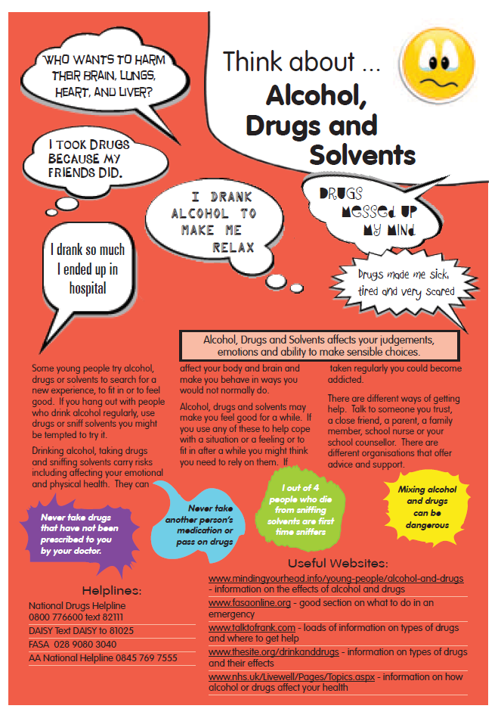
Appendix 5
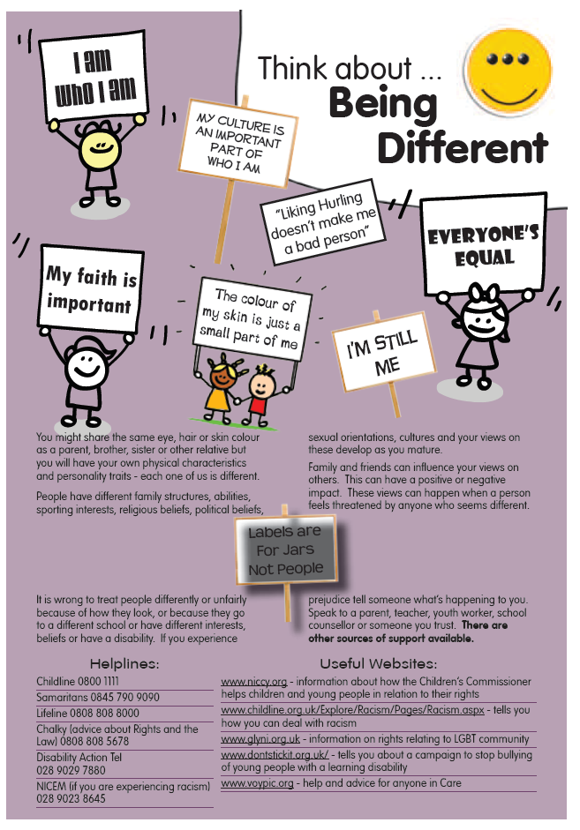
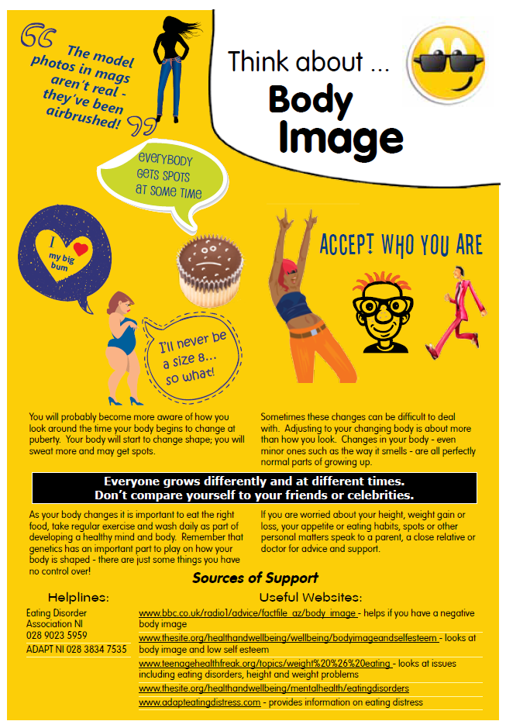
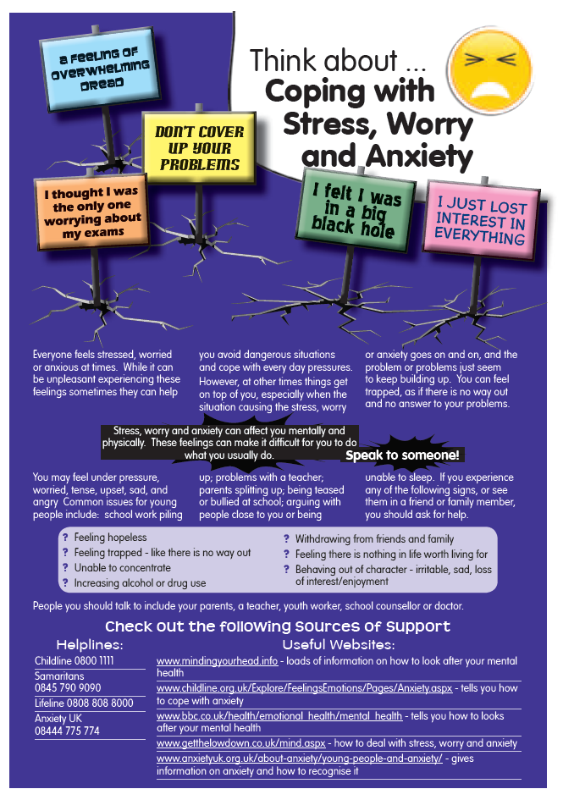

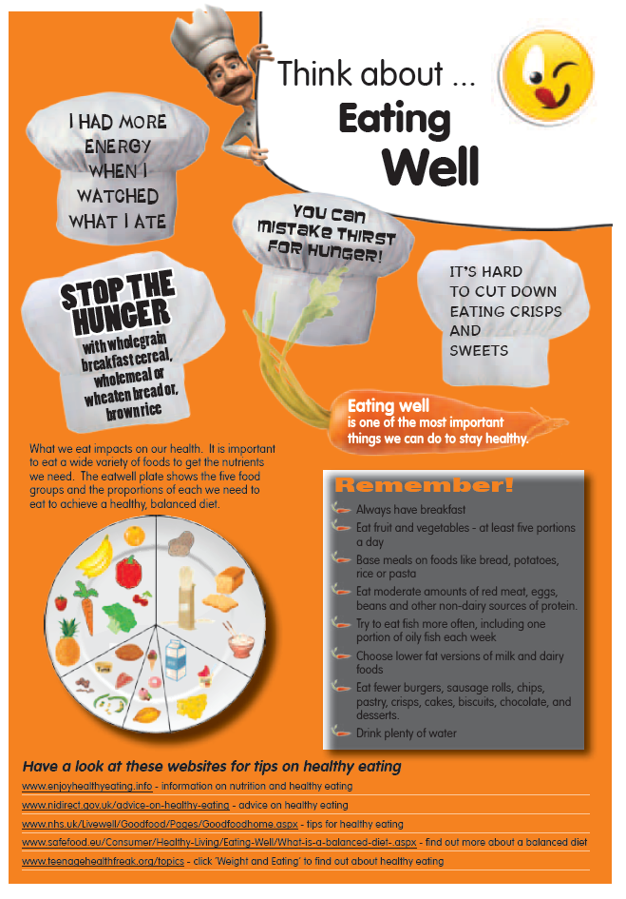

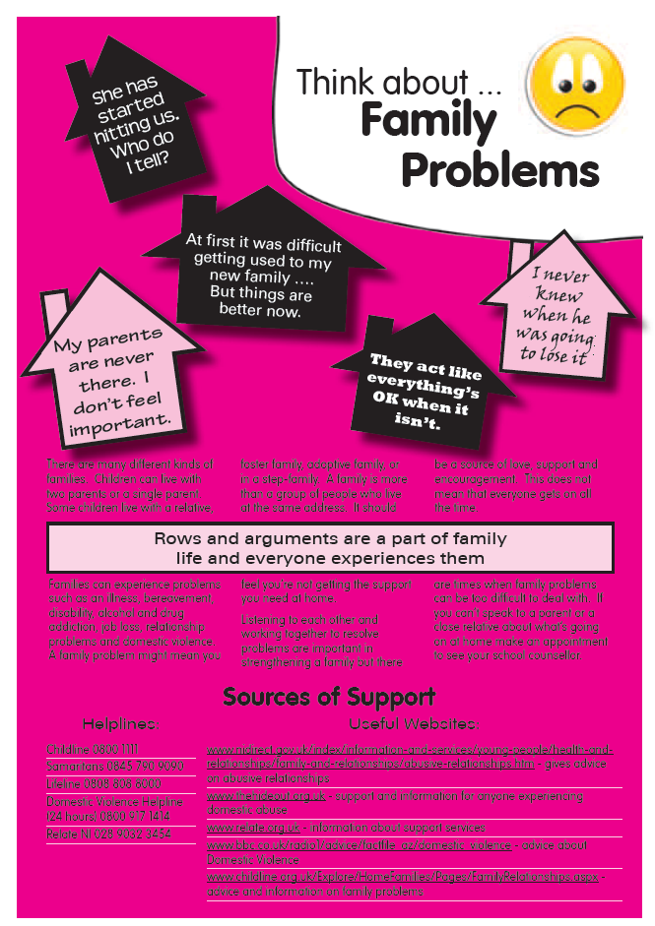
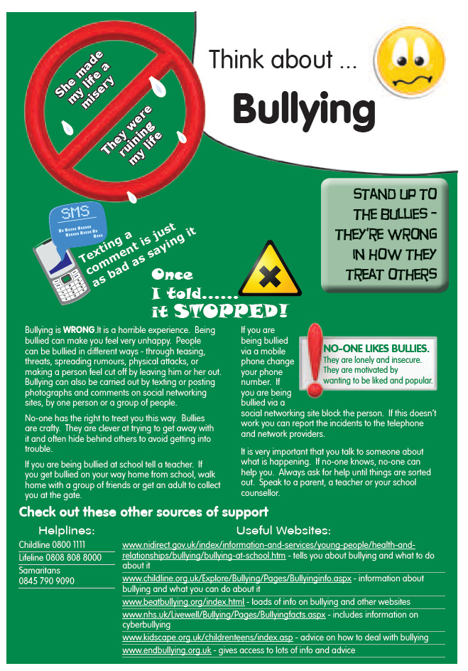

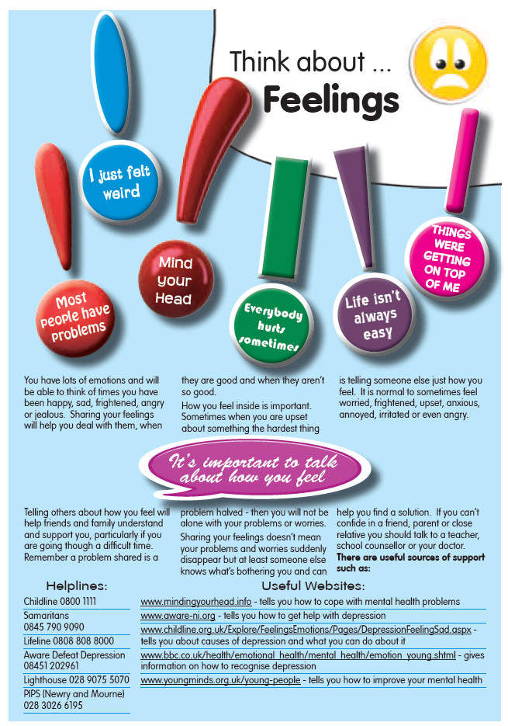

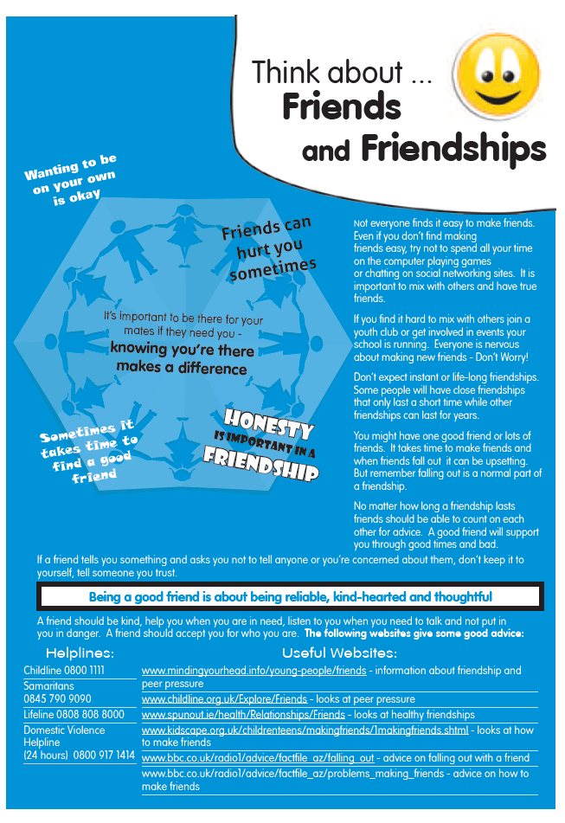
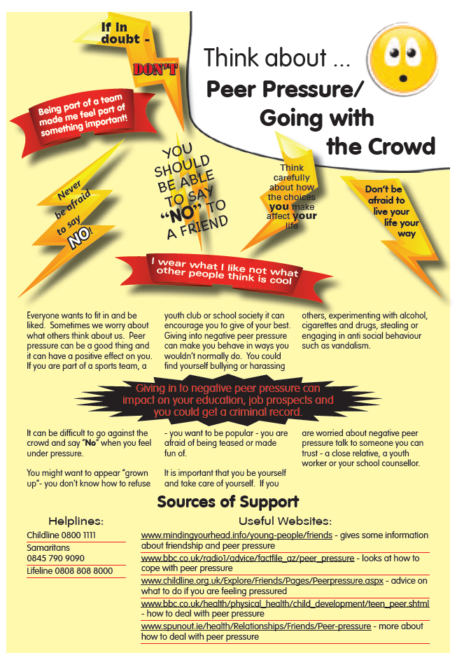

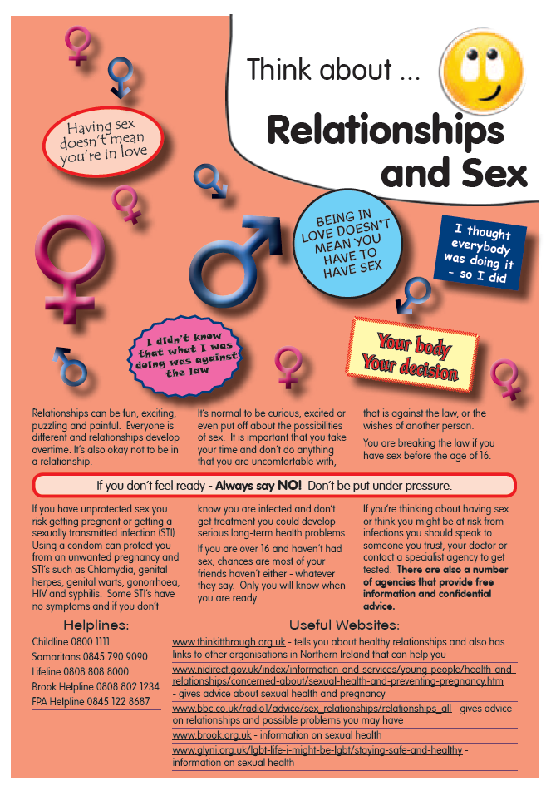
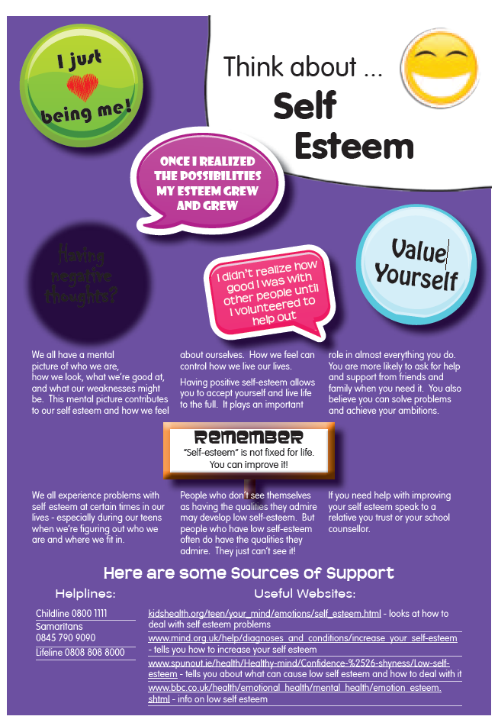
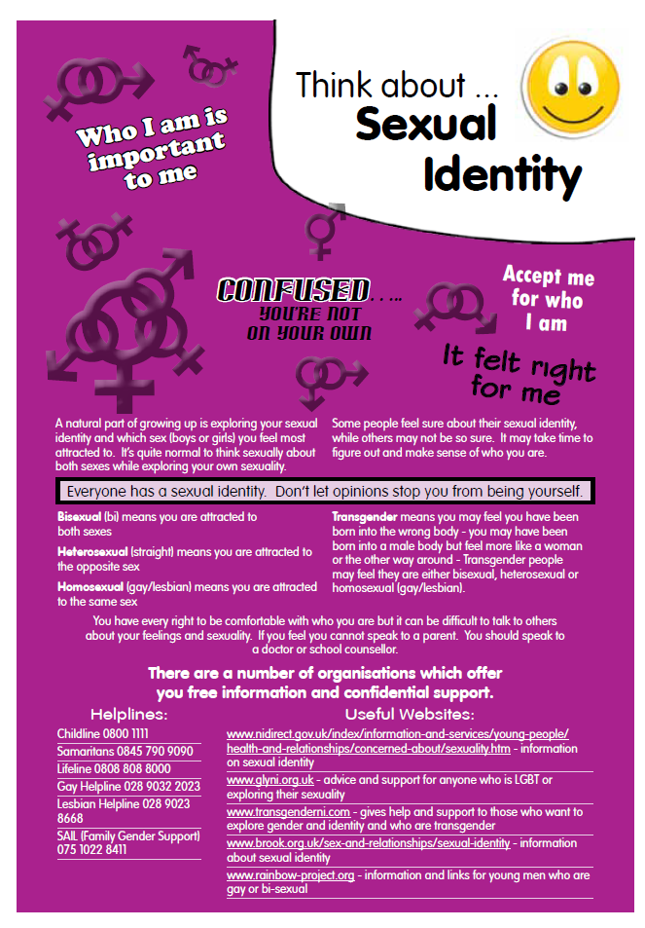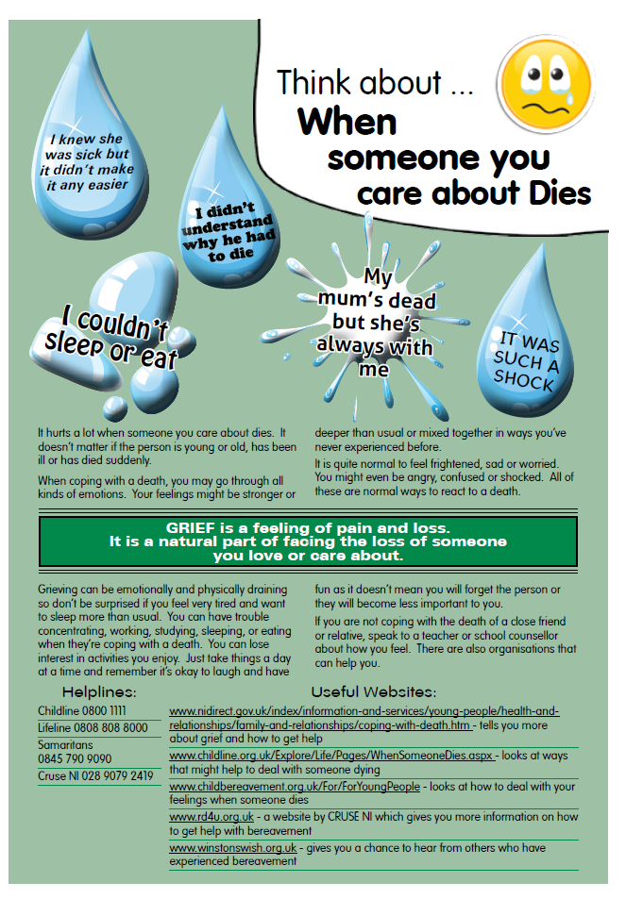

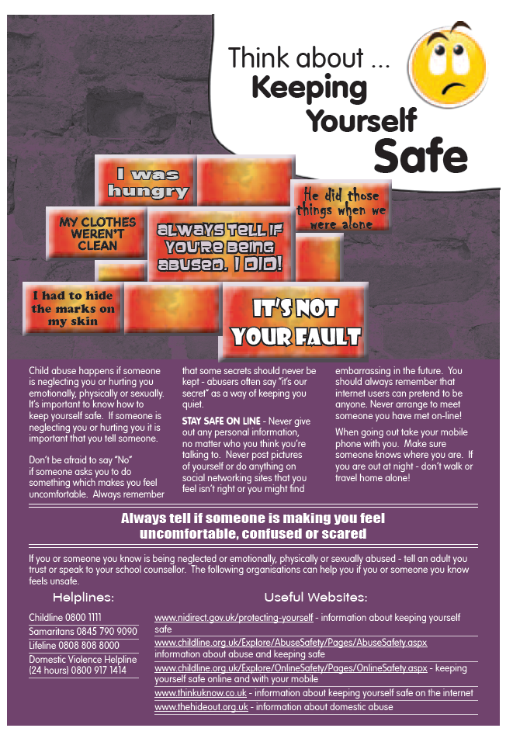

Relationship and Sexuality Education Policy

Signed: (Chairman of Board of Governors)

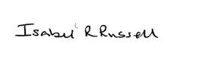

Signed: (Principal)

Date: 4 May 2022

Board of Governors Meeting held on 4 May 2022

Next Review Date: June 2023

In this document the term ‘transgender’ refers to any young person whose gender identity or expression differs from the expectations placed upon them, regardless of how they identify (e.g. whether they identify as transgender, trans, non-binary, gender queer, gender fluid, non-gendered or gender questioning).
Social transition usually involves a young person wearing clothes, adopting a different name or using the facilities which corresponds with their gender identity.
In Youth Service, this will be the ‘worker in charge’, with support from the Senior Youth Officer
Throughout this briefing, ‘parents’ should be taken to include all those with parental responsibility, including guardians and carers
CCEA (2018): Relationships and Sexuality Education Guidance, Section 3
Article 3 of the United Nations Convention on the Rights of the Child
Including those employees whose work is in or takes them into a school setting or voluntary youth work setting, should also make themselves familiar with any policies pertinent to those settings
Article 3 of the United Nations Convention on the Rights of the Child. Also note that under Article 3 1(a) of the Children (Northern Ireland) Order 1995 in any proceedings where a court determines any question with respect to the upbringing of a child, the child’s welfare shall be the court’s paramount consideration
Department of Education (2018): Every school a good school – the governors’ role. A Guide for Governors
‘Coming out’ is a term used to describe the process through which a person realises that they are lesbian, gay, bisexual or transgender and may begin to share this aspect of their identity with others.
Department of Education (2015): Circular 2015/22 - Relationship and Sexuality Education (RSE) Guidance
Also see guidance from ETI on Relationships and Sexuality Education in Primary and Special Schools – report of an evaluation by the Education and Training Inspectorate
General Teaching Council for Northern Ireland’s Code of Values and Professional Practice, page 5
Education Authority (2017): Interim Strategic Plan (2017-27), page 12
ECNI Website: Good Practice: A transgender pupil
CCEA (2018): Relationships and Sexuality Education Guidance, Section 3

