Post 16 Application Process
Holy Trinity College warmly invites students in Year 12 and those from other Post-Primary schools, who wish to return to full-time study in Sixth Form in September 2022, to join them in a virtual Year 12 to Post 16 Transition Overview via the College Website.
On the website you will find important information with regard to Subjects offered: AS Academic Subjects / Applied Subjects, BTEC Nationals or a combination of subject pathways, and an overview of life in the College.
Alternatively, please visit the College on Thursday 25th August from 9.30am – 2.30pm for our Post 16 Open Day and take the opportunity to speak to Subject Staff and Careers Team, ensuring best advice and guidance for A Level Study.
The Post 16 Prospectus can also be found on the College website www.holytrinitycollege.org
Online Applications may be submitted via the Google Doc link on or before Wednesday 24 August 2022.
Holy Trinity College Pupils: https://forms.gle/h2b5oLv4gXnpTkX49
For External Applicants: https://forms.gle/5TXgm4Mmg4M4dHRN6
Choose either Option Route 1 or 2: All students must study a minimum of 3 subjects.
- A choice of 3 or 4 individual subjects from Route 1: Options 1-4
- Double Award Subject plus a single award from Route 2
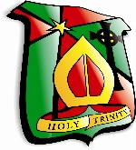
Post 16 Options 2022-23
Route One
Option One | Option Two | Option Three | Option Four
English Literature  History  Geography  Maths | Sociology  Art  Health and Social Care  Sports Studies (Single Award) | Biology  Religion  Business Studies  Physics (CHS)  Music Performing (Single Award)  Travel & Tourism | Chemistry  Psychology  Media Studies (Single Award)  Agriculture (Single Award)  ICT (Single Award)  Engineering

Route Two
Double Award | Option Two
DA Art  DA Music Performing  DA Sports Studies | Chemistry  Psychology  Media Studies (Single Award)  Agriculture (Single Award)  ICT (Single Award)  Engineering

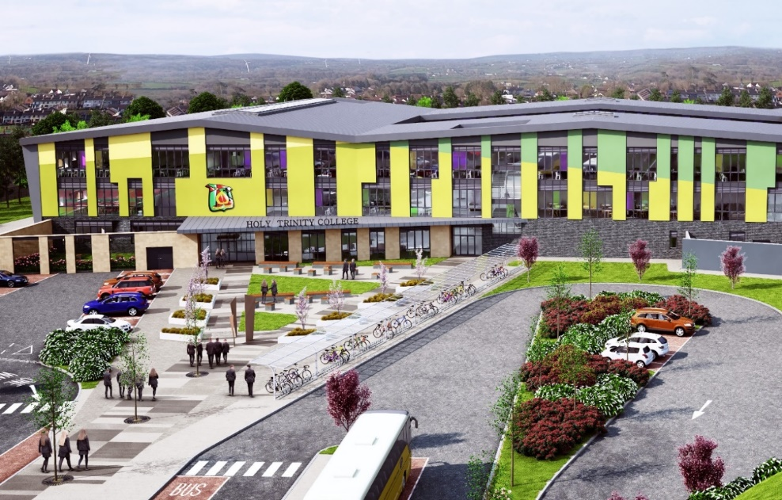
Please Note: Subjects may be withdrawn on the grounds of insufficient numbers.

